

PROJECT PROPOSAL

Deliverable 1

**Proposal and content** 







|  |
| --- |
| TABLE OF CONTENTS |

TABLE OF CONTENTS 1

2. CLIENT INFORMATION 3

Introduction 3

2.1 History and Background 3

2.2 ORGANISATION DESCRIPTION 3

2.2.1 ORGANISATIONAL STRUCTURE 4

2.2.2 GEOGRAPHICAL LOCATION 4

2.3 Contact Person 5

Conclusion 6

3. project request 7

Introduction 7

3.1 Project Request 7

Conclusion 7

4. Preliminary investigation 8

Introduction 8

4.1 Problem Matrix 8

4.2 Preliminary Scope of the Project 9

4.3 Preliminary Constraints Identified 10

4.4 Other Project Related Issues 11

CONCLUSION 12

5. Problem Analysis 13

Introduction 13

5.1 Executive summary 13

5.2 Background information 13

5.3 Overview of current system 14

5.4.1 Analysis of current system 15

5.4.2 Rich Picture 16

5.5 Detailed recommendations 17

conclusion 18

6. Requirment analysis 19

Introduction 19

6.1 User requirements list 19

6.2 requirement description and detail 21

6.2 USER ACCCEPTANCE CRITERIA OF FINAL SYSTEM 40

**USER ACCEPTANCE CRITERIA** 40

**USER ACCEPTANCE CRITERIA** 40

**USER ACCEPTANCE CRITERIA** 41

6.2.1 Use Cases 42

conclusion 44

7. DECISION ANALYSIS 45

7.1 Introduction 45

7.2.1 FEASIBILITY ANALYSIS 46

7.2.2 Details of each Alternatives 49

7.2 RECOMMENDATIONS 52

conclusion 52

8. APPENDIX A: CLIENT DOCUMENTATION 53

Introduction 53

8.1 Documents 53

conclusion 62

9. APPENDIX B: OTHER SYSTEMS INVESTIGATED 63

Introduction 63

9.1 LITERATURE STUDY 63

9.2 GAP ANALYSIS REPORT 78

conclusion 81

10. APPENDIX C: COMPLEXITY 82

Introduction 82

10.1 Complexity Matrix 82

conclusion 85

11. SIGN OFF 86

Introduction 86

11.1 sign off 86

conclusion 87

|  |
| --- |
| 2. CLIENT INFORMATION |



## Introduction

This is a short description of our client and their business. It conveys their history, who they are, what they have to offer and where they are heading in the future.

## 2.1 History and Background

The name of the company is derived from a Venda word “Ndila” which means “Road”. Ndila was formed in November 2007. The founder of the company who is currently the CEO of the business is Mr. DHMJEE

Ndila Transfers are a company based in Gauteng and Western Cape with the aim of supplying affordable, professional, safe and reliable 24-hour shuttle services to the South African tourism industry and to the corporate industry. Their services are reliant on the following values Respect, Reliability, Integrity, Flexibility and Professionalism. They have the capacity to transport their esteemed clients safely to any respective destination from either Gauteng or Western Cape.

They cater for transfer requests around south Africa whether it’s airport, concert, event or meeting, they collect their clients from any location.

## 2.2 ORGANISATION DESCRIPTION

Ndila transfers has put its name in the mouths of many with its award-winning services, working as a business to business and business to consumer transfers company. Ndila Transfers offers the following services:

* Airport Transfer: Transporting clients to and from the airports
* Business Transfers: Transporting clients to their destination (office or business meetings, homes)
* Point to point: Personal transportation of clients from one destination to another
* Events Transfer: Transport guests and materials
* Document Delivery: Transfer documents from point a to be across the country.

## 2.2.1 ORGANISATIONAL STRUCTURE

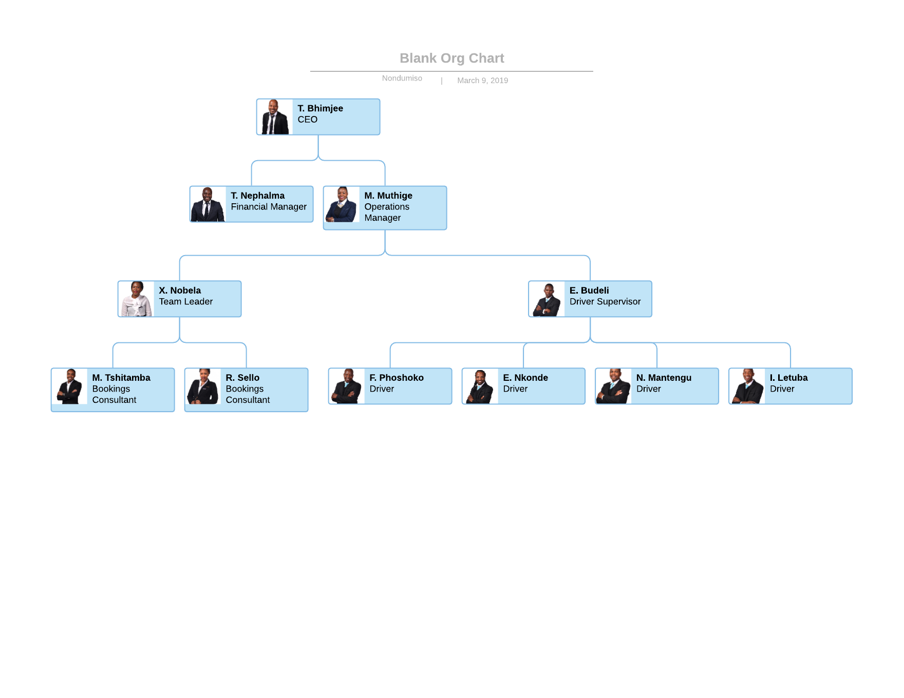

## 2.2.2 GEOGRAPHICAL LOCATION

Ndila Transfers is located at:

* 753 Park St, Acardia, Pretoria, 0002
* Plus-Code: 66X9+R6 Pretoria

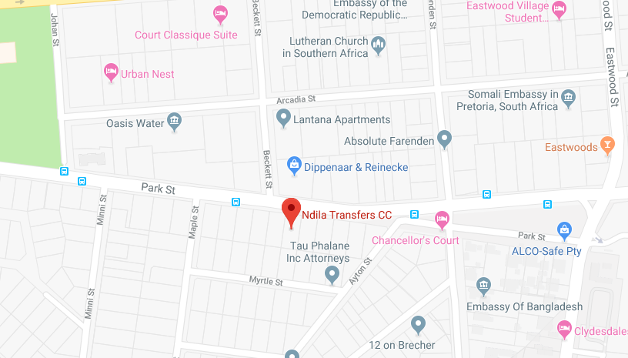

## 2.3 Contact Person



Mr. Thendo Nephalma

Financial Manager

061 402 6227

[Thendo@ndilatransfers.com](mailto:Thendo@ndilatransfers.com)

Our direct contact person is Mr. Thendo Nephalma who works as the finance manager for Ndila Transfers. He started working for the company in 2013 as a part time financial clerk, helping with the company’s accounting journals and other related finance documents. As from 2015 he started working as a full time Financial Manager, handling all the accounting reports for the company, analyzing company journals and communicating with the CEO with regards to new business strategies and financial.

## Conclusion

This serves as a full compilation of the company’s details and direct contact person’s information

|  |
| --- |
| 3. project request |



## Introduction

A project request is a simple description that specifies the details of a new project. Why the project should be done and what are the benefits of the proposed project.

## 3.1 Project Request

Ndila transfers currently works on a manual paper-based system to capture all their daily operations such as bookings, client pick up confirmation, invoices etc. Manual systems take longer to complete simple operations such as bookings and paper-based systems that give storage problems, that are prone to damage and human error. The system (**Siyaya Travel Assist**) to be built for NdilaTransfers will assist with automating their booking system, helping them build a database for their clients and help make record keeping more effective and efficient.

## Conclusion

**Siyaya Travel Assist** is an application that will help solve the business problem mentioned above. It comes as a solution to automate the booking and communication system.

|  |
| --- |
| 4. Preliminary investigation |



## Introduction

We will start by identifying the problem definition which will be specified using a problem matrix, then we will continue by stating the scope of the project and all constraints and other project related issues that we have identified.

## 4.1 Problem Matrix

|  |  |  |  |  |  |
| --- | --- | --- | --- | --- | --- |
| **Brief Statements of Problem, Opportunity, or Directive** | **Urgency** | **Visibility** | **Annual Benefits** | **Priority or Rank** | **Proposed Solution** |
| 1. Recording of information of clients through email | 6 months | High | In the thousands | 4 | Create a database to record booking details and client information |
| 1. Transfer cards (for bookings) are written down on paper | 6 months | High | In the thousands | 3 | Capture booking information and generate a report of the booking |
| 1. Communication done through sending an SMS to inform drivers of new work load | 6 months | High | In the thousands | 3 | The system will automatically send “SMS” to driver upon dispatch |
| 1. Communication done through sending an SMS to inform client of booking confirmation | 6 months | High | In the thousands | 3 | The system will automatically send “SMS” to client to confirm booking |
| 1. No database for clients to keep client information | 6 months | High | In the thousands | 4 | Keep client information stored in the database |
| 1. No formal structured reports for Sales, clients, inventory etc. | 6 months | Medium | In the thousands | 3 | Generates the required reports from the system |
| 1. Manual typing of Allocation email | 6 months | High | In a thousand | 3 | Send email from the system; allowing user to select client from database |

*Table 1 : Problem Matrix*

## 4.2 Preliminary Scope of the Project

**Project Scope**

**Stakeholders**

|  |  |  |
| --- | --- | --- |
| Name | Role | Internal/External |
| Kwena Maboka | Team Member | Internal |
| Mninikhaya Mavundla | Team Member | Internal |
| Mpho Mosotho | Team Member | Internal |
| Nondumiso Mahlangu | Team Member (Leader) | Internal |
| Paballo Matabane | Team Member | Internal |
| Thendo Nelphalma | Client Contact | External |
| Dr Lizette Weilbach | Assessor | External |
| Dr Riana Steyn | Assessor | External |

*Table 2: Stakeholders*

**Purpose of project**

**Background**

Our Client runs a shuttle services company for the past few years. We as a team have decided to help them to move from their old paper-based system and to a new modern computer-based information system. The current system that Ndila Transfers is using however short-falls that we aim to overcome so that these issues are resolved with our new proposed system.

**Deliverables**

Project will be divided into 12 deliverables which all entail different requirements and work to do be completed:

DELIVERABLE 0 – TEAM & CLIENT INFORMATION

DELIVERABLE 1 – PROJECT PROPOSAL

DELIVERABLE 2 – FUNCTIONAL SPECIFICATION

DELIVERABLE 3 – PROTOTYPE

DELIVERABLE 4 – TECHNICAL DESIGN AND TEST SPECIFICATIONS

DELIVERABLE 5 – INTERNALLY TESTED SYSTEM

DELIVERABLE 6 – SYSTEM DOCUMENTATION

DELIVERABLE 7 – PROJECT REPOSITORY

DELIVERABLE 8 – TESTED SYSTEM

DELIVERABLE 9 – USER DOCUMENTATION

DELIVERABLE 10 – PROJECT DAY

DELIVERABLE 11 – SYSTEMS VIDEO

## 4.3 Preliminary Constraints Identified

**Hardware Constrains:**

Outdated hardware specifications and incompatibility between hardware and the systems software could lead to major problems for the **Siyaya Travel assist** management system to be efficient and fully functional, a minimum computer system of Intel Pentium VI – 1000 MHz Processor or above, with at least 512MB of RAM and at least 10 GB Hard space, for server configuration with Internet Explorer 6.0 or higher or any compatible browser installed.

**Hardware solutions:** Upgrade hardware (e.g. add additional memory, increase hard disk storage capacity, replace cards)

**Project development costs:**

Mostly a constraint for the client side as they may be a development cost for the software licensing that they might need to pay to use system as their own.

**Costs Solution:** Inform the client well beforehand of any hidden costs that might be needed to own the developed information system.

**Software Constrains:**

The OS platform for this software should be any 32-bit version of Microsoft

Windows Operating system Microsoft Windows 7 flat form with,

* Microsoft SQL Management studio 14
* Oracle Version 10
* Internet Explorer 6.0 or higher or any compatible browser

**Systems Software solutions:** Upgrade software, Buy or build off-the-shelf.

**Unrealistic Deadlines:**

Time is a big concern as our development team consists mainly of students who have other important modules to add to their schedules and some are working on a part time basis as well.

**Solution:** Break the project up into a series of smaller milestones or deliverables and set a group deadline for each. This will keep us on-track for the final deadline

**Security Constraints:**

The clerk(admin) and management personnel will require different access levels with valid id and password to login to the system.

**Solution**: A reliable and proven firewall software is needed to secure the data inside the system from outside users.

**Project Funding:**

A lot of printing will take place to document the project as well as other internal expenses such as the purchasing of T-shirts, digitalization of the group logo and other unexpected costs included.

**Solution**: start a Strategic Project Fund for the team where each member contributes a certain amount of money for all the related project cost we might incur.

**Lack of skills and expertise**

This will be the first full functional system the team develops, evidently there is no experience in dealing with a real-life client, so time needs to be taken out to develop these skills.

**Solution**: Set out a personal skills development manual on the skills we individually lack in and use the resources at our deposal e.eg consultation hours.

**Systems quality:**

The team acknowledges that with its inexperience in developing fully functional systems as a constrain as confidence in our work meeting industry standards is currently at a low but with the university’s help this should soon not be a problem.

**Solution:** Consult with the lectures and tutors on a regular basis and use collaboration software like GitHub to ask for advice on related project issues.

## 4.4 Other Project Related Issues

**Improper communication channels:**

Difficulties that the team and all relevant stakeholders may experience trying to clearly communicate information. Troubles related to information sharing can lead to many other serious problems.

**Solution**: Develop a way to inform what information needs to be informed to the team members and relevant stakeholders. Using collaboration software to ensure to ensure stakeholders are in the loop of recent activities in the project.

**Risk Management:**

Risk management: Often life doesn’t for as planned, the same as a project so risk management is one of the major management issues that the team must deal with, these risks can be an uncertainty e.g. hidden flaws in the project plan or unknown factor that can impact the success of the project.

**Solution**: It’s impossible to predict every potential risk with strategic planning and collecting information beforehand, we can anticipate which part of the project is likely to fail.

**Lack of experience in using project management software:**

According to studies two-third of successful projects used project management software for managing their projects and communication purposes with no experience in this kind of software and management strategies this might lead to problems later in the project.

**Solution**: learn how to use at-least one project management software that the whole team can use.

**Issues within the team**

Issues and incongruities amongst team members is a challenge for the project.

**Solution**: The best way to eliminate any issues or negativity the team might experience is to create a positive work environment.

**Consistency in documentation**

Documentation and printing are required to document the project this might course problem as all deliverables need to be consistent.

**Solution**: This might be solved if one person within the team does the compiling of the documentation with the help of other team members.

## CONCLUSION

This is the study of a problem, prior to taking some action. It refers to the study of the business area or application, usually leading to the specification of a new system.

|  |
| --- |
| 5. Problem Analysis |



## Introduction

Problem analysis is the process of understanding real-world problems and user's needs and proposing solutions to meet those needs.

## 5.1 Executive summary

The problem analysis compiled in this document looks to identify the specifications for the new system and continue to identify all the requirements. By using this analysis strategy, we will be able to the shortcomings of the current system.

The outcome of the of the analysis identified that the main business functionalities present the most problems as they are all manually operated and these operations turn to be less efficient and have a high risk of human error. There are also a few inconsistencies that we have identified and a few redundancies too.

By looking into the processes and operations we will apply solution strategies such as objective analysis and benchmarking to come up with solutions that will be viable to not only eliminate all the problems but to make the system effective and efficient

## 5.2 Background information

N**dila Transfers** is company founded in November 2007, based in Gauteng and the Western Cape that offers affordable, professional, safe reliable shuttle services to the South African tourism industry and to the corporate industry. The name of the company is derived from a Venda word “Ndila” which means “Road”, hence Ndila (Road) Transfers. The founding members of Ndila have the necessary qualifications and experience to put Ndila Transfers in the for-front when it comes to providing Road transport. Their drivers went through a hefty selection process where they check their qualifications and their experience in the chauffeur industry. Ndila Transfers **vision** is to become the preferred shuttle service provider across the tourism and corporate industry and its **mission** is to provide professional, safe, reliable and timeous service to all esteemed clients. Ndila Transfers services are based and reliant on the following v**alues**

* **Professionalism**
* **Reliability**
* **Respect**
* **Integrity**
* **Flexibility**

## 5.3 Overview of current system

The current system is **manually based**; the company receives calls or emails from their clients. In case of a new client can either be an agency or private client, a quotation of the prices and the list will be sent to the client through the email or will be communicated over the phone. The client will then choose the deal they want, for an agency they will request a voucher card from the company that will be used for claiming after the trip is done. For individuals they will request a deposit. The arrangement of the trip is written down on a paper called transfer card is just a summary of the trip. Then they will put that paper in a cabinet for future reference, they use a calendar to keep track of their schedules.

The **transfer cards** are grouped according to weeks. If the trip is a week later is placed on future dates. The booking consultants; every week they shift the previous trips to another cabinet. In a case where they must retrieve details of the client they have to search that transfer card in the cabinet

Voucher cards are sent to the company from the agency as a confirmation of the trip from their side, it includes the costs of the trip and information about the client they will be collecting from either the airport, home or office

**Trip allocation**

Drivers receive an email and SMS about the trips they going to take. The allocation is done by the driver supervisor. The email consists of the client details such as contact number, names and the pickup and drop off point.

The company has no reporting system everything is done on paper; they don’t have the database to keep track of their client details.

## 5.4.1 Analysis of current system

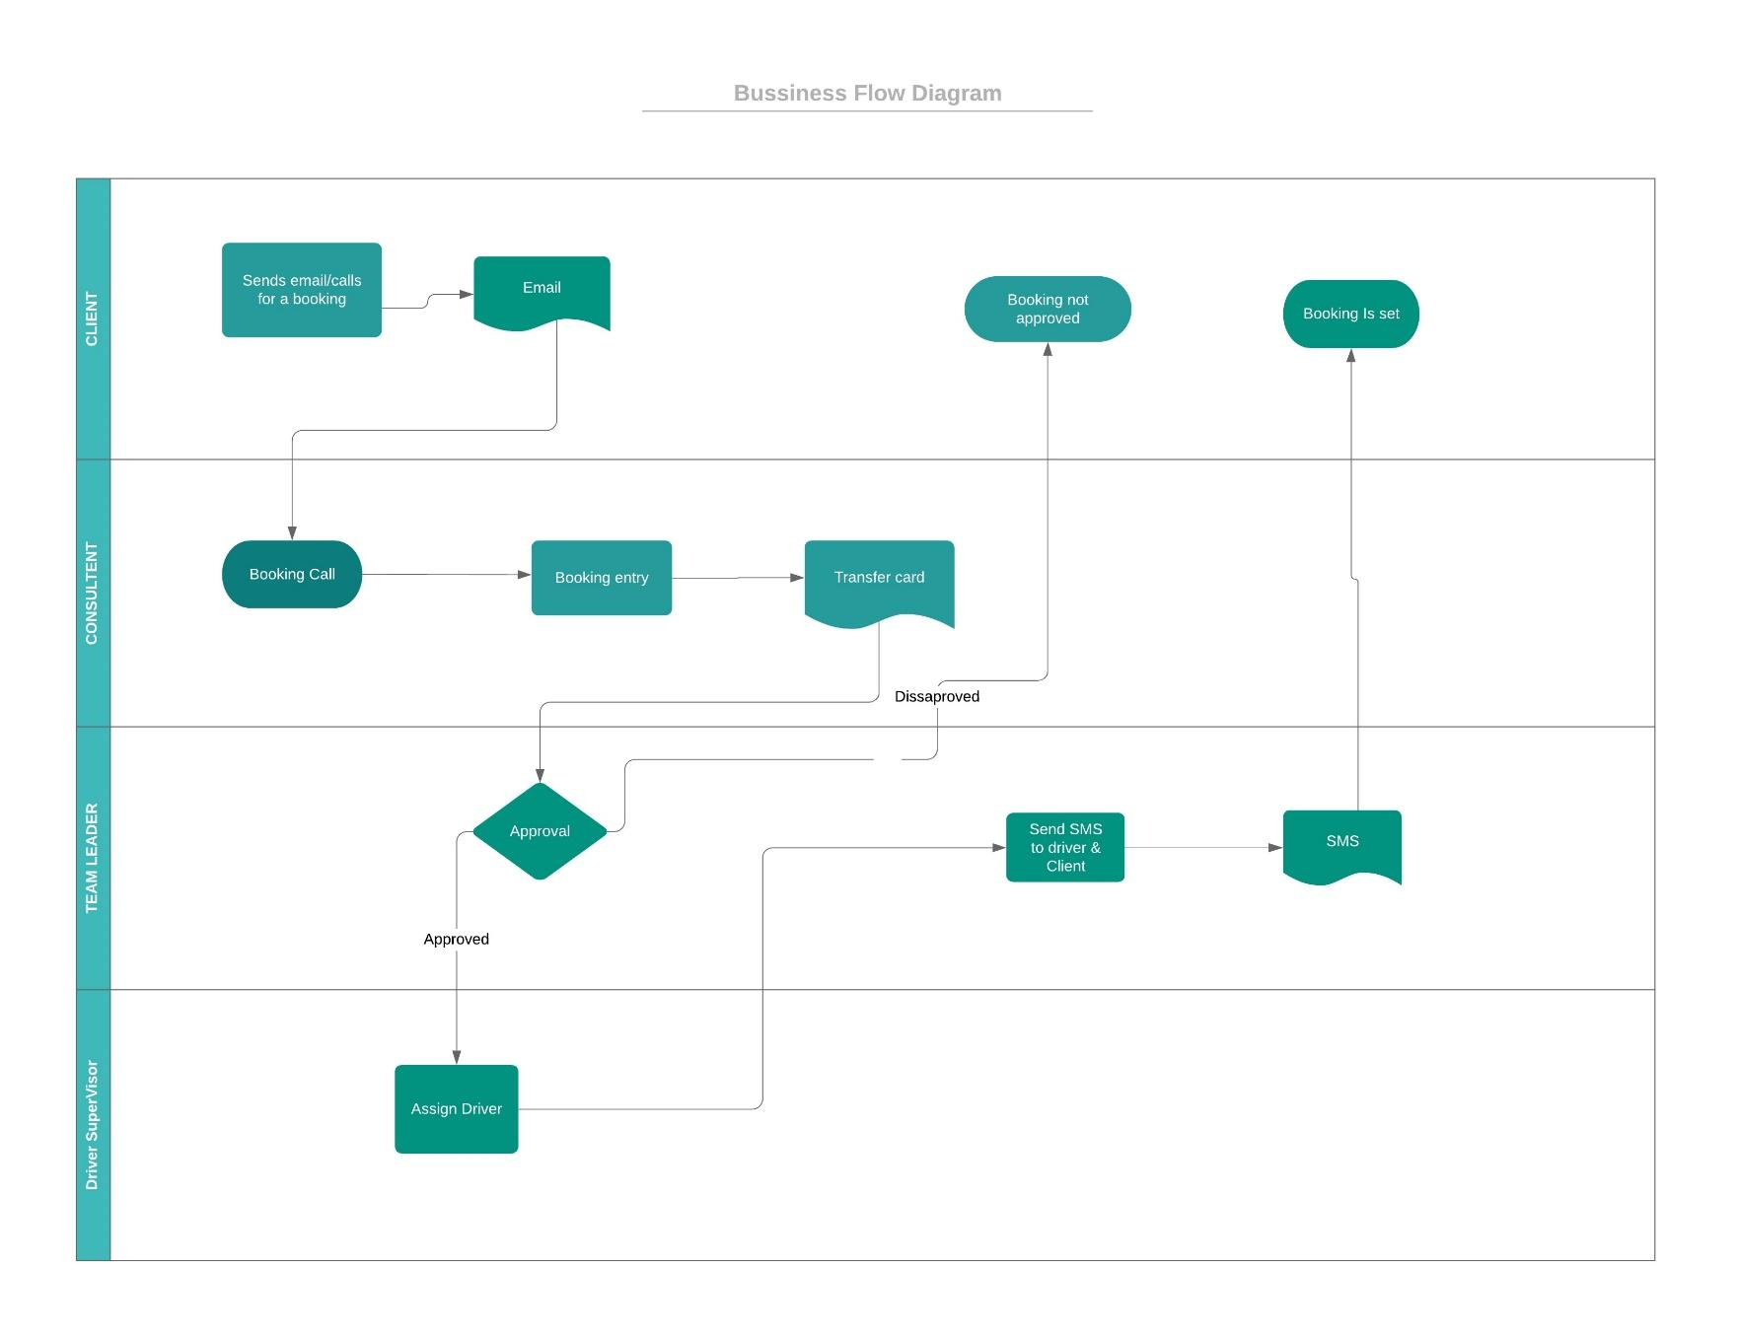

## 5.4.2 Rich Picture

**Agency/Private Client Email or Call**

Booking Consultant



Booking set

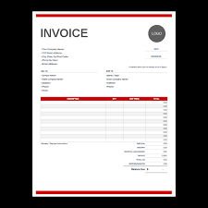Invoice 

**Quote**



**Confirms Trip**

 

**Driver** **Driver Supervisor** **Team Leader**

**Assign Driver (SMS) Approves trip**

## 5.5 Detailed recommendations

|  |  |  |  |  |
| --- | --- | --- | --- | --- |
| **CAUSE AND EFFECT ANALYSIS** | | **SYSTEM IMPROVEMENT OBJECTIVES** | | |
| **Problem or Opportunity** | **Causes and Effects** | **System Objective** | **System Constraint** |
| 1. The current system doesn’t create automated reports to management. | * Business won’t see its direction or pitfalls. * Creates inconvenience when management wants to make business related decisions. | * To create automated reports. * To create guidance for management. | * If data in the system is incorrect or not up to date, reports won’t be accurate. |
| 2. The system is outdated and mostly manual. Data is stored in files which is stored in a cabinet. | * Vital client information is not secured. * Possible loss of data. | * Client information will be secured. * Eliminate possible loss of data. * Restrict access to information through user access levels. | * A good database is required. * Back up size will be limited to financial limitations of the company |
| 3. Overbooking tends to occur during busy periods | * Driver bookings system is completed manually on the day of the trip * Booking cancellations and last-minute bookings | * To create a booking system ensures that double bookings and overbookings don’t occur by restricting double bookings | * Inaccurate data/information is captured into the system * Clients changing their booking information at the last minute |
| 4. Scheduling meetings is done manually | * Meeting attendants do not necessarily know how to prepare for the set meeting * People aren’t always available to attend the meeting because they’re too busy | * Create a meeting scheduler which will let the all the attendants about the agenda of the meeting. * Meeting can then be scheduled at times where all required attendants are available | * Internet connection is required * Correct information should be entered into the system |
| 5. Quotes are generated manually | * Therefore, quotes can contain misleading information or even inaccurate sums of money | * To auto generate quotation based on preset rates which are set by system manager | * Correct information should be entered into the system |

*Table 3: POOC*

## conclusion

After reading this section a clear and thorough description of the problems in the current system will be visible. These problems will not only be addressed but the appropriate modifications and improvements must be noted and approved of so that the system can be modified in a manner which will produce the optimal output with the least amount of inputs. A clear view of the current system will be visible to the reader allowing him/her to understand the modifications to the system and why these improvements will make the system function in the most optimal fashion.

|  |
| --- |
| 6. Requirment analysis |



## Introduction

In this section a complete and thorough analysis of client requirements will be given. This includes all the business requirements needed inside the organization for the system to function in the most optimal manner. These requirements include privileges and other specifications which will added complexity constraints to the system. This section will help give the reader information about what the business wants the system to do and how they want it to be done, who the individuals are whom are involved in the actions of the system and how the system responds to these actions

## 6.1 User requirements list

|  |
| --- |
| 1. User Login (Employees) |
| * 1. Register New User |
| * 1. Remove User |
| * 1. Update User |
| * 1. Search User |
| * 1. User Type |

|  |
| --- |
| 1. User Type |
| * 1. Create User Type |
| * 1. Update User Date |
| * 1. Search User Type |
| * 1. Remove User Type |

|  |
| --- |
| 1. Audit Trail |
| * 1. Access Level |
| * 1. Update Access Level |
| * 1. Remove Access Level |
| * 1. Search Access Level |

|  |
| --- |
| 1. Drivers |
| * 1. Register Driver |
| * 1. Search Driver |
| * 1. Update Driver |
| * 1. Dispatch Driver |

|  |
| --- |
| 1. Clients |
| * 1. Register Client |
| * 1. Update Client |
| * 1. Search Client |
| * 1. Remove Client |

|  |
| --- |
| 1. Vehicles |
| * 1. Register Vehicle |
| * 1. Search Vehicle |
| * 1. Update Vehicle |
| * 1. Dispatch Vehicle |

|  |
| --- |
| 1. Vehicle Type |
| * 1. Create Vehicle Type |
| * 1. Search Vehicle Type |
| * 1. Remove Vehicle Type |
| * 1. Update Vehicle Type |

|  |
| --- |
| 1. Booking |
| * 1. Create Booking |
| * 1. Update Booking |
| * 1. Cancel Booking |
| * 1. Search Booking |

|  |
| --- |
| 1. Booking Type |
| * 1. Create Booking Type |
| * 1. Search Booking Type |
| * 1. Remove Booking Type |
| * 1. Update Booking Type |

|  |
| --- |
| 1. Quotations |
| * 1. Create Quote |
| * 1. Remove Quote |
| * 1. Search Quote |

|  |
| --- |
| 1. Reporting |
| * 1. Generate Bookings Report |
| * 1. Generate Vehicle Report |

|  |
| --- |
| 1. Maintenance (Service) |
| * 1. Schedule Maintenance Plan |
| * 1. Search Maintenance Plan |
| * 1. Remove Maintenance Plan |
| * 1. Update Maintenance Plan |

|  |
| --- |
| 1. Location |
| * 1. Create New Location |
| * 1. Update Location |
| * 1. Search Location |
| * 1. Remove Location |

|  |
| --- |
| 1. Zone Rate |
| * 1. Create Zone |
| * 1. Update Zone |
| * 1. Search Zone |
| * 1. Remove Zone |

## 6.2 requirement description and detail

|  |  |
| --- | --- |
| Requirement | Explanation |
| Requirement number: | 1.1 |
| Requirement title: | Register New User |
| Requirement text: | The system must allow the user to registered to the system |
| Requirement type: | Functional Requirement |
| Requirement details and constraints: | The user’s personal details such as full names, ID number, contact details, gender, age, race, marriage status, contact ICE, physical/postal address, User’s employee details such as position and date of appointment.  Only users that are employed by the company can be registered to use the system by the admin. |
| Revision date and Revision number: | 2019-02-28  Version 2 |
| Criticality/Priority: | High |

|  |  |
| --- | --- |
| Requirement | Explanation |
| Requirement number: | 1.2 |
| Requirement title: | Update User |
| Requirement text: | The system must allow the user details to be updated. |
| Requirement type: | Functional Requirement |
| Requirement details and constraints: | User details to update, but firstly an ID number should be provided to search the user or user can go to update profile and update their personal details such as contact details, full names.  Only registered users can update their own personal details, the Admin can update all the registered users |
| Revision date and Revision number: | 2019-02-28  Version 2 |
| Criticality/Priority: | High |

|  |  |
| --- | --- |
| Requirement | Explanation |
| Requirement number: | 1.3 |
| Requirement title: | Search User |
| Requirement text: | The system must search user’s details from the database and retrieve them if they are found or state otherwise with a message that the user is not registered |
| Requirement type: | Functional Requirement |
| Requirement details and constraints: | The system will need user ID (ID number) to be able to check if the user exists in the database. Details of the user will only be retrieved if they exist in the database else an error message will be displayed stating the user is not registered. The user must be logged in first to enable them to search and needs admin access to search other users |
| Revision date and Revision number: | 2018-02-28  Version 2 |
| Criticality/Priority: | Medium |

|  |  |
| --- | --- |
| Requirement | Explanation |
| Requirement number: | 2.1 |
| Requirement title: | Create User Type |
| Requirement text: | The system must allow the user to create a new user type |
| Requirement type: | Functional Requirement |
| Requirement details and constraints: | The name of the user type either CEO, manager (Finance or operational), driver supervisor, driver, team leader or booking consultant. It must be a registered position in the company and only the admin can create the user type |
| Revision date and Revision number: | 2019-02-28  Version 2 |
| Criticality/Priority: | High |

|  |  |
| --- | --- |
| Requirement | Explanation |
| Requirement number: | 2.2 |
| Requirement title: | Update User Type |
| Requirement text: | The system must allow the admin to update the user type |
| Requirement type: | Non-Functional Requirement |
| Requirement details and constraints: | The details of the user type such as access level, description of the user type. Only admin can update the user type details |
| Revision date and Revision number: | 2019-02-28  Version 2 |
| Criticality/Priority: | High |

|  |  |
| --- | --- |
| Requirement | Explanation |
| Requirement number: | 2.3 |
| Requirement title: | Search User Type |
| Requirement text: | The system must allow the admin to search the user types that exist in the system and retrieve the details |
| Requirement type: | Non-Functional Requirement |
| Requirement details and constraints: | The details of the user type to be searched such as the name of the user type and admin can only search for the user type |
| Revision date and Revision number: | 2019-02-28  Version 2 |
| Criticality/Priority: | Medium |

|  |  |
| --- | --- |
| Requirement | Explanation |
| Requirement number: | 2.4 |
| Requirement title: | Remove User Type |
| Requirement text: | The system must allow the admin to remove the User Type if it’s no more needed in the company |
| Requirement type: | Non-Functional Requirement |
| Requirement details and constraints: | The name of the user type will be required to be searched and removed. Can only be removed if there’s no user assigned to it |
| Revision date and Revision number: | 2019-02-28  Version 2 |
| Criticality/Priority: | High |

|  |  |
| --- | --- |
| Requirement | Explanation |
| Requirement number: | 3.1 |
| Requirement title: | Create Access Level |
| Requirement text: | The system must allow the restriction of access level can either be an admin or general access. |
| Requirement type: | Non-Functional Requirement |
| Requirement details and constraints: | The admin access level give access to a full operation of the system the general users cannot edit other employee’s details or cannot remove user types or other employees from the system. |
| Revision date and Revision number: | 2019-02-28  Version 2 |
| Criticality/Priority: | High |

|  |  |
| --- | --- |
| Requirement | Explanation |
| Requirement number: | 3.2 |
| Requirement title: | Update Access Level |
| Requirement text: | The system must allow modification of access level such as updating the restrictions of users |
| Requirement type: | Non-Functional Requirement |
| Requirement details and constraints: | The name of the access level to be updated and the rules or restrictions to be updated |
| Revision date and Revision number: | 2019-02-28  Version 2 |
| Criticality/Priority: | Low |

|  |  |
| --- | --- |
| Requirement | Explanation |
| Requirement number: | 3.3 |
| Requirement title: | Remove Access Level |
| Requirement text: | The system must allow the removal of access level if it is no more needed in the system |
| Requirement type: | Non-Functional Requirement |
| Requirement details and constraints: | The access level can only be removed if there is no user assigned to that access level and the name of the access level should be provided. |
| Revision date and Revision number: | 2019-02-28  Version 2 |
| Criticality/Priority: | Low |

|  |  |
| --- | --- |
| Requirement | Explanation |
| Requirement number: | 4.1 |
| Requirement title: | Register Driver |
| Requirement text: | The system must allow the registration of drivers to the system |
| Requirement type: | Functional Requirement |
| Requirement details and constraints: | The driver’s personal details such as full names, age, gender, citizenship, ID number, License details and contact details, Years of driving. The driver should have valid license and Identity documents. |
| Revision date and Revision number: | 2019-02-28  Version 2 |
| Criticality/Priority: | High |

|  |  |
| --- | --- |
| Requirement | Explanation |
| Requirement number: | 4.2 |
| Requirement title: | Search Driver |
| Requirement text: | The system must allow the retrieval of the driver details from the database |
| Requirement type: | Functional Requirement |
| Requirement details and constraints: | The Driver’s valid ID number or name can be used to retrieve the details of the driver from the database, Details such as full names, contact details and license information. |
| Revision date and Revision number: | 2019-02-28  Version 2 |
| Criticality/Priority: | High |

|  |  |
| --- | --- |
| Requirement | Explanation |
| Requirement number: | 4.3 |
| Requirement title: | Update Driver |
| Requirement text: | The system must allow the admin to update the driver details such as full names, contact details, license information |
| Requirement type: | Non-Functional Requirement |
| Requirement details and constraints: | The details of the driver that needs to be updated on the system such as contact details, license information and full names. The admin can only update the details of the driver |
| Revision date and Revision number: | 2019-02-28  Version 2 |
| Criticality/Priority: | Medium |

|  |  |
| --- | --- |
| Requirement | Explanation |
| Requirement number: | 4.4 |
| Requirement title: | Dispatch Driver |
| Requirement text: | The system must allow the allocation of trips to drivers and update their availability on that day |
| Requirement type: | Functional Requirement |
| Requirement details and constraints: | The driver ID and full names to check if the driver is available on the day. The details of trips within a certain area on that day and allocate them to the specific driver |
| Revision date and Revision number: | 2019-02-28  version 2 |
| Criticality/Priority: | High |

|  |  |
| --- | --- |
| Requirement | Explanation |
| Requirement number: | 5.1 |
| Requirement title: | Register Client |
| Requirement text: | The system must allow clients to be added to the system upon requesting for services |
| Requirement type: | Functional Requirement |
| Requirement details and constraints: | The client details such as name of the company (in a case of an agency), contact details, Direct contact person details such as ID number, full names. The client must have requested to use the service |
| Revision date and Revision number: | 2019-02-28  Version 2 |
| Criticality/Priority: | High |

|  |  |
| --- | --- |
| Requirement | Explanation |
| Requirement number: | 5.2 |
| Requirement title: | Update Client |
| Requirement text: | The system must allow the updating of client details |
| Requirement type: | Functional Requirement |
| Requirement details and constraints: | The client should provide the details they would like to update can either be contact details or names or if they want to change the direct person of contact. |
| Revision date and Revision number: | 2019-02-28  Version 2 |
| Criticality/Priority: | High |

|  |  |
| --- | --- |
| Requirement | Explanation |
| Requirement number: | 5.3 |
| Requirement title: | Search Client |
| Requirement text: | The system must allow the booking consultant to check for clients on the system using either their names or client ID to retrieve details |
| Requirement type: | Functional Requirement |
| Requirement details and constraints: | The booking consultant should provide the client ID or their name to retrieve their details. The client should be registered in the system to retrieve the details of the client |
| Revision date and Revision number: | 2019-02-28  Version 2 |
| Criticality/Priority: | High |

|  |  |
| --- | --- |
| Requirement | Explanation |
| Requirement number: | 5.4 |
| Requirement title: | Remove Client |
| Requirement text: | The system must allow the Removal of a client from the system |
| Requirement type: | Functional Requirement |
| Requirement details and constraints: | The name or the ID of the client to search it on the system to select the client to remove. The client should not have a historical debt or pending trip |
| Revision date and Revision number: | 2019-02-28  Version 2 |
| Criticality/Priority: | High |

|  |  |
| --- | --- |
| Requirement | Explanation |
| Requirement number: | 6.1 |
| Requirement title: | Register Vehicle |
| Requirement text: | The system must allow the adding of new vehicles to the system |
| Requirement type: | Functional Requirement |
| Requirement details and constraints: | The details of the vehicle such as registration plate, color, model, date bought and kilos to complete for service. The operation manager must be logged in, to perform the operations |
| Revision date and Revision number: | 2019-02-28  Version 2 |
| Criticality/Priority: | High |

|  |  |
| --- | --- |
| Requirement | Explanation |
| Requirement number: | 6.2 |
| Requirement title: | Search Vehicle |
| Requirement text: | The system must allow the retrieval of vehicle’s details if it exist in the system |
| Requirement type: | Functional Requirement |
| Requirement details and constraints: | The registration plate of the vehicle should be provided to retrieve the details such as the model and color, date bought, kilometers travelled. |
| Revision date and Revision number: | 2019-02-28  Version 2 |
| Criticality/Priority: | High |

|  |  |
| --- | --- |
| Requirement | Explanation |
| Requirement number: | 6.3 |
| Requirement title: | Update Vehicle |
| Requirement text: | The system must allow the user to update the vehicle details. |
| Requirement type: | Functional Requirement |
| Requirement details and constraints: | The vehicle registration plate to search the vehicle and retrieve the details of the vehicle. The user will provide the details that needs to be updated. |
| Revision date and Revision number: | 2019-02-28  Version 2 |
| Criticality/Priority: | High |

|  |  |
| --- | --- |
| Requirement | Explanation |
| Requirement number: | 6.4 |
| Requirement title: | Dispatch Vehicle |
| Requirement text: | The system must assign a vehicle to a driver 24 hours before the trip |
| Requirement type: | Functional Requirement |
| Requirement details and constraints: | The driver’s details and the available vehicle’s registration plate. To assign a driver a vehicle for the trip he will take. There must be a booked trip |
| Revision date and Revision number: | 2019-02-28  Version 2 |
| Criticality/Priority: | High |

|  |  |
| --- | --- |
| Requirement | Explanation |
| Requirement number: | 7.1 |
| Requirement title: | Create Vehicle type |
| Requirement text: | The system must allow to add a new vehicle type to the system |
| Requirement type: | Functional Requirement |
| Requirement details and constraints: | The vehicle type is classified according to the classes for instance class A is standard cars such as corolla professional, class B is standard BMW and so forth. |
| Revision date and Revision number: | 2019-02-28  Version 2 |
| Criticality/Priority: | High |

|  |  |
| --- | --- |
| Requirement | Explanation |
| Requirement number: | 7.2 |
| Requirement title: | Search Vehicle Type |
| Requirement text: | The system must allow the booking consultant to search for the type of vehicles they have |
| Requirement type: | Functional Requirement |
| Requirement details and constraints: | The name of the vehicle type should be provided, and the system will reflect which cars are assigned to that type of vehicle and the details of the type such as the costs, descriptions |
| Revision date and Revision number: | 2019-02-28  Version 2 |
| Criticality/Priority: | High |

|  |  |
| --- | --- |
| Requirement | Explanation |
| Requirement number: | 7.3 |
| Requirement title: | Remove Vehicle Type |
| Requirement text: | The system must allow the removal of the vehicle type, |
| Requirement type: | Functional Requirement |
| Requirement details and constraints: | The name of the vehicle type should be provided to retrieve it from the database, so it could be removed if it is no longer necessary to the company. The vehicle type should not be assigned to any vehicle |
| Revision date and Revision number: | 2019-02-28  Version 2 |
| Criticality/Priority: | High |

|  |  |
| --- | --- |
| Requirement | Explanation |
| Requirement number: | 7.4 |
| Requirement title: | Update vehicle type |
| Requirement text: | The system must allow the vehicle type to be update |
| Requirement type: | Functional Requirement |
| Requirement details and constraints: | The vehicle type details that needs to be updated should be provided. Details such as costs and descriptions. The vehicle type should exist in the system |
| Revision date and Revision number: | 2019-02-28  Version 2 |
| Criticality/Priority: | Medium |

|  |  |
| --- | --- |
| Requirement | Explanation |
| Requirement number: | 8.1 |
| Requirement title: | Create Booking |
| Requirement text: | The system must allow a booking to be captured to the system |
| Requirement type: | Functional Requirement |
| Requirement details and constraints: | The type of client can either be an agency or individual client, the type of transfer they want (transportation to airport, document or from home to office and the other way around).  The booking details such as pickup and drop off location, date and time, contact details of the person to be collected and extra information about the trip of the client. And email or a phone call is made to the company to generate the booking |
| Revision date and Revision number: | 2019-02-28  Version 2 |
| Criticality/Priority: | High |

|  |  |
| --- | --- |
| Requirement | Explanation |
| Requirement number: | 8.2 |
| Requirement title: | Update Booking |
| Requirement text: | System must allow the booking details to be updated upon request |
| Requirement type: | Functional Requirement |
| Requirement details and constraints: | The details about the booking that needs to be updated. In a case of contact details have changed |
| Revision date and Revision number: | 2019-02-28  Version 2 |
| Criticality/Priority: | High |

|  |  |
| --- | --- |
| Requirement | Explanation |
| Requirement number: | 8.3 |
| Requirement title: | Cancel Booking |
| Requirement text: | The system must allow the user to cancel a booking upon request |
| Requirement type: | Functional Requirement |
| Requirement details and constraints: | The name of the booking or Booking ID, when a client requests to cancel a booking, The system needs to check the time of cancelation and compare it with the time needed to get to the venue and if it’s less than the cancelation time then a go ahead will be approved with no additional cost else not they will be charged to pay 100% of the trip |
| Revision date and Revision number: | 2019-02-28  Version 2 |
| Criticality/Priority: | High |

|  |  |
| --- | --- |
| Requirement | Explanation |
| Requirement number: | 8.4 |
| Requirement title: | Search Booking |
| Requirement text: | The system should allow the user to search for a booking and retrieve the details of the booking |
| Requirement type: | Functional Requirement |
| Requirement details and constraints: | The Booking ID of the client to preview the details such as date, pickup and drop off location, contact details. |
| Revision date and Revision number: | 2019-02-28  Version 2 |
| Criticality/Priority: | Medium |

|  |  |
| --- | --- |
| Requirement | Explanation |
| Requirement number: | 9.1 |
| Requirement title: | Create Booking Type |
| Requirement text: | The system must allow the user to add a new booking type to the database |
| Requirement type: | Functional Requirement |
| Requirement details and constraints: | The name of the booking and the details of the booking type can either be a personal booking or agency booking, descriptions and conditions that go with the booking type will be required. The booking type shouldn’t exist in the database |
| Revision date and Revision number: | 2019-02-28  Version 2 |
| Criticality/Priority: | High |

|  |  |
| --- | --- |
| Requirement | Explanation |
| Requirement number: | 9.2 |
| Requirement title: | Search Booking Type |
| Requirement text: | The system must allow the retrieval of details assigned to a specific booking type |
| Requirement type: | Functional Requirement |
| Requirement details and constraints: | The name of the booking type should be provided to retrieve the details from the database such as the Terms and conditions assigned to it. |
| Revision date and Revision number: | 2019-02-28  Version 2 |
| Criticality/Priority: | Medium |

|  |  |
| --- | --- |
| Requirement | Explanation |
| Requirement number: | 9.3 |
| Requirement title: | Remove Booking Type |
| Requirement text: | The system must allow the removal of the booking type |
| Requirement type: | Functional Requirement |
| Requirement details and constraints: | The name of the booking type to retrieve it from the database, so the admin can remove it from the database. The booking type shouldn’t be assigned to any client and must exist in the database |
| Revision date and Revision number: | 2019-02-28  Version 2 |
| Criticality/Priority: | Medium |

|  |  |
| --- | --- |
| Requirement | Explanation |
| Requirement number: | 9.4 |
| Requirement title: | Update Booking Type |
| Requirement text: | The system must allow the modification of the booking type |
| Requirement type: | Functional Requirement |
| Requirement details and constraints: | The name of the booking type to retrieve it from the database and the necessary details such as terms and conditions that need to be updated. The booking type should exist in the database. |
| Revision date and Revision number: | 2019-02-28  Version 2 |
| Criticality/Priority: | High |

|  |  |
| --- | --- |
| Requirement | Explanation |
| Requirement number: | 10.1 |
| Requirement title: | Create Quotation |
| Requirement text: | The system must allow user to generate a new Quotation |
| Requirement type: | Functional Requirement |
| Requirement details and constraints: | All Transfer details: total cost, schedule for work, quote expiry date, business details, client information, contact info. |
| Revision date and Revision number: | 2019-02-28  Version 2 |
| Criticality/Priority: | High |

|  |  |
| --- | --- |
| Requirement | Explanation |
| Requirement number: | 10.2 |
| Requirement title: | Remove Quotation |
| Requirement text: | The system must allow user to remove a quotation on the database |
| Requirement type: | Functional Requirement |
| Requirement details and constraints: | Using requirement 11.4 (Search Quotation) to retrieve client Invoice. User can remove the relevant Client Quotation |
| Revision date and Revision number: | 2019-02-28  Version 2 |
| Criticality/Priority: | High |

|  |  |
| --- | --- |
| Requirement | Explanation |
| Requirement number: | 10.3 |
| Requirement title: | Search Quotation |
| Requirement text: | The system must allow user to search an existing quotation in the database |
| Requirement type: | Functional Requirement |
| Requirement details and constraints: | Search using Quote ID. Quote ID is generated when the requirement 11.1 (Create Quotation) is executed. |
| Revision date and Revision number: | 2019-02-28  Version 2 |
| Criticality/Priority: | High |

|  |  |
| --- | --- |
| Requirement | Explanation |
| Requirement number: | 11.1 |
| Requirement title: | Booking Report |
| Requirement text: | The system must allow user to generate a report for a transfer booking |
| Requirement type: | Functional Requirement |
| Requirement details and constraints: | A client ID is required to search for the relevant client and the system should be able to return all the bookings made by that specific client using their client. Results shown should be: Booking date, pick-up location and drop-off location, price, zone. |
| Revision date and Revision number: | 2019-02-28  Version 2 |
| Criticality/Priority: | High |

|  |  |
| --- | --- |
| Requirement | Explanation |
| Requirement number: | 11.2 |
| Requirement title: | Vehicle Report |
| Requirement text: | The system must allow user to generate a report for vehicles that have been booked out. |
| Requirement type: | Functional Requirement |
| Requirement details and constraints: | This will search for all vehicles that are booked out for maintained and give out a report of all unavailable vehicles. |
| Revision date and Revision number: | 2019-02-28  Version 2 |
| Criticality/Priority: | High |

|  |  |
| --- | --- |
| Requirement | Explanation |
| Requirement number: | 12.1 |
| Requirement title: | Create Schedule Maintenance Plan |
| Requirement text: | The system must allow user to book in a vehicle for maintenance |
| Requirement type: | Functional Requirement |
| Requirement details and constraints: | The user adds a vehicle using the Vehicle ID to the maintenance plan table |
| Revision date and Revision number: | 2019-02-28  Version 2 |
| Criticality/Priority: | High |

|  |  |
| --- | --- |
|  | Explanation |
| Requirement number: | 12.2 |
| Requirement title: | Search Schedule Maintenance |
| Requirement text: | The system must allow user to search for vehicles that are out for maintenance or have a schedule maintenance |
| Requirement type: | Functional Requirement |
| Requirement details and constraints: | The user will use the Vehicle ID to retrieve details of the specific vehicle. The vehicle should be registered with the company also have a service plan |
| Revision date and Revision number: | 2019-02-28  Version 2 |
| Criticality/Priority: | High |

|  |  |
| --- | --- |
| Requirement | Explanation |
| Requirement number: | 12.3 |
| Requirement title: | Remove Schedule Maintenance Plan |
| Requirement text: | The system must allow the removal of schedule maintenance plan. |
| Requirement type: | Functional Requirement |
| Requirement details and constraints: | The vehicle ID will be used to retrieve the vehicle that needs to be removed from schedule maintenance plan |
| Revision date and Revision number: | 2019-02-28  Version 2 |
| Criticality/Priority: | High |

|  |  |
| --- | --- |
| Requirement | Explanation |
| Requirement number: | 12.4 |
| Requirement title: | Update Schedule Maintenance Plan |
| Requirement text: | The system must allow user to update a vehicle that is back from maintenance or a vehicle that is going on maintenance |
| Requirement type: | Functional Requirement |
| Requirement details and constraints: | The system must allow user to update a vehicle that is back from maintenance or a vehicle that is going on maintenance using the vehicle ID |
| Revision date and Revision number: | 2019-02-28  Version 2 |
| Criticality/Priority: | High |

|  |  |
| --- | --- |
| Requirement | Explanation |
| Requirement number: | 13.1 |
| Requirement title: | Create New Location |
| Requirement text: | The system must allow user to add a new location |
| Requirement type: | Functional Requirement |
| Requirement details and constraints: | Details of the location such as Country, Province, City, town/Suburb, Street Number and name. Booking consultants adds location. |
| Revision date and Revision number: | 2019-02-28  Version 2 |
| Criticality/Priority: | High |

|  |  |
| --- | --- |
| Requirement | Explanation |
| Requirement number: | 13.2 |
| Requirement title: | Update Location |
| Requirement text: | The system must allow user to update the location |
| Requirement type: | Functional Requirement |
| Requirement details and constraints: | The system must allow user to update the location of specific destination that has been saved |
| Revision date and Revision number: | 2019-02-28  Version 2 |
| Criticality/Priority: | High |

|  |  |
| --- | --- |
| Requirement | Explanation |
| Requirement number: | 13.3 |
| Requirement title: | Search Location |
| Requirement text: | The system must allow user to search for a location |
| Requirement type: | Functional Requirement |
| Requirement details and constraints: | Input of destination should serve as automatic searching. If location is not in database, then a “no results found” will be displayed. |
| Revision date and Revision number: | 2019-02-28  Version 2 |
| Criticality/Priority: | Must |

|  |  |
| --- | --- |
| Requirement | Explanation |
| Requirement number: | 14.1 |
| Requirement title: | Create Zone |
| Requirement text: | The system must allow user to add a zone to the system |
| Requirement type: | Functional Requirement |
| Requirement details and constraints: | Each zone is related to a certain price that is used to calculate the price of the trip. System should allow user to add a new zone .details such as price and range in kilometers |
| Revision date and Revision number: | 2019-02-28  Version 2 |
| Criticality/Priority: | High |

|  |  |
| --- | --- |
| Requirement | Explanation |
| Requirement number: | 14.2 |
| Requirement title: | Update Zone |
| Requirement text: | The system must allow user to update the price associated with the zone |
| Requirement type: | Functional Requirement |
| Requirement details and constraints: | System should allow the user to change the price rate for the specified zone. Operational manager/ admin access can perform the operation |
| Revision date and Revision number: | 2019-02-28  Version 2 |
| Criticality/Priority: | High |

|  |  |
| --- | --- |
| Requirement | Explanation |
| Requirement number: | 14.3 |
| Requirement title: | Search Zone |
| Requirement text: | The system must allow user to search the price associated with the zone |
| Requirement type: | Functional Requirement |
| Requirement details and constraints: | The system should allow the user to search for the specific zone allowing it to retrieve the relevant price associated with the zone |
| Revision date and Revision number: | 2019-02-28  Version 2 |
| Criticality/Priority: | High |

|  |  |
| --- | --- |
| Requirement | Explanation |
| Requirement number: | 14.4 |
| Requirement title: | Remove Zone |
| Requirement text: | The system must allow user to remove a zone |
| Requirement type: | Functional Requirement |
| Requirement details and constraints: | The name of the zone to be removed and should not be assigned to any trip. The admin can only remove the zone. |
| Revision date and Revision number: | 2019-02 -28  Version 2 |
| Criticality/Priority: | High |

## 6.2 USER ACCCEPTANCE CRITERIA OF FINAL SYSTEM

The communication between the client and the development team plays a vital role in delivering a solution that fits system and company requirements. The issues arise if customers explain their needs too vaguely and the team can’t understand clear requirements and eventually the business problem behind them. Acceptance criteria (AC) are the conditions that a software product must meet to be accepted by a user, a customer, or other system.

**Scenario-oriented acceptance criteria:**

**User story**: As a booking consultant I want to be able to connect to the system and be able to make a booking with my access level code.

Scenario: **Making a booking**

|  |  |
| --- | --- |
| Given | There’s a booking to be made |
| When | The client called or email to make a booking |
| And | Consultant enter their access code and login on the system |
| Then | The system logs the user in to make a booking. |

### **USER ACCEPTANCE CRITERIA**

* user enters access level code
* system Authorisation of code
* System logs user in

**User story**: As a financial manage I want to be able to make a request for a quote from the system so that I will be able to receive the quote from my access level account quickly and in different places.

Scenario: **Request a Quote**

|  |  |
| --- | --- |
| Given | There’s a booking made |
| When | The client called or email to make a booking and it has been confirmed |
| And | Financial manager requests a quote on the system |
| Then | The system logs in the manger and display the quote |

### **USER ACCEPTANCE CRITERIA**

* Booking confirmed by the system
* System Authorisation of code for manger
* System logs user in
* System displays request

**User story:**  As a booking consultant I need to be able to confirm the booking with the driver and the client to book them for that specific trip on the system

Scenario: **Sending a message through a valid email address.**

|  |  |
| --- | --- |
| Given | The email address is valid or phone number. |
| When | The email address is authenticated. |
| Then | The message is sent to the email address. |

### **USER ACCEPTANCE CRITERIA**

* system Authorisation of code for consultant
* System logs consultant in
* Consultants enters drivers and client’s details.
* Authorisation of email address
* System sends out the email.

## 6.2.1 Use Cases

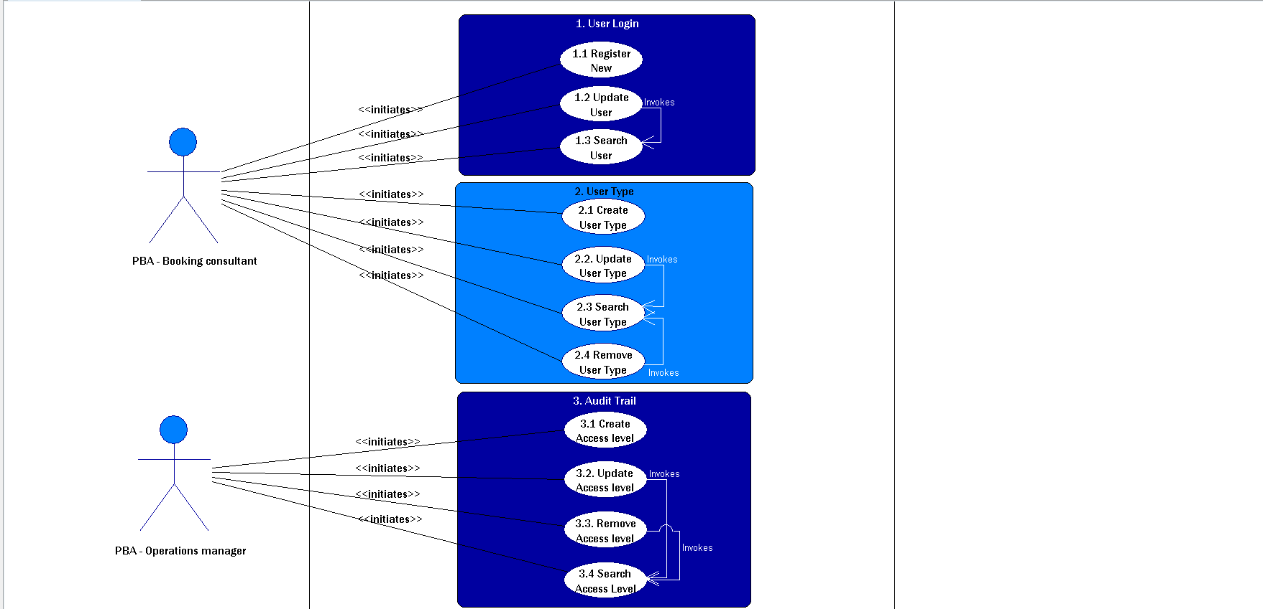

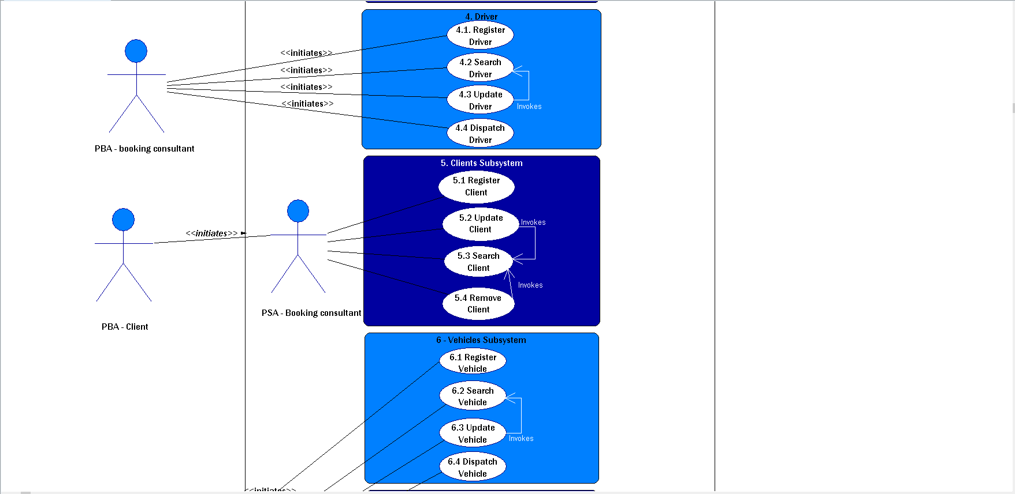

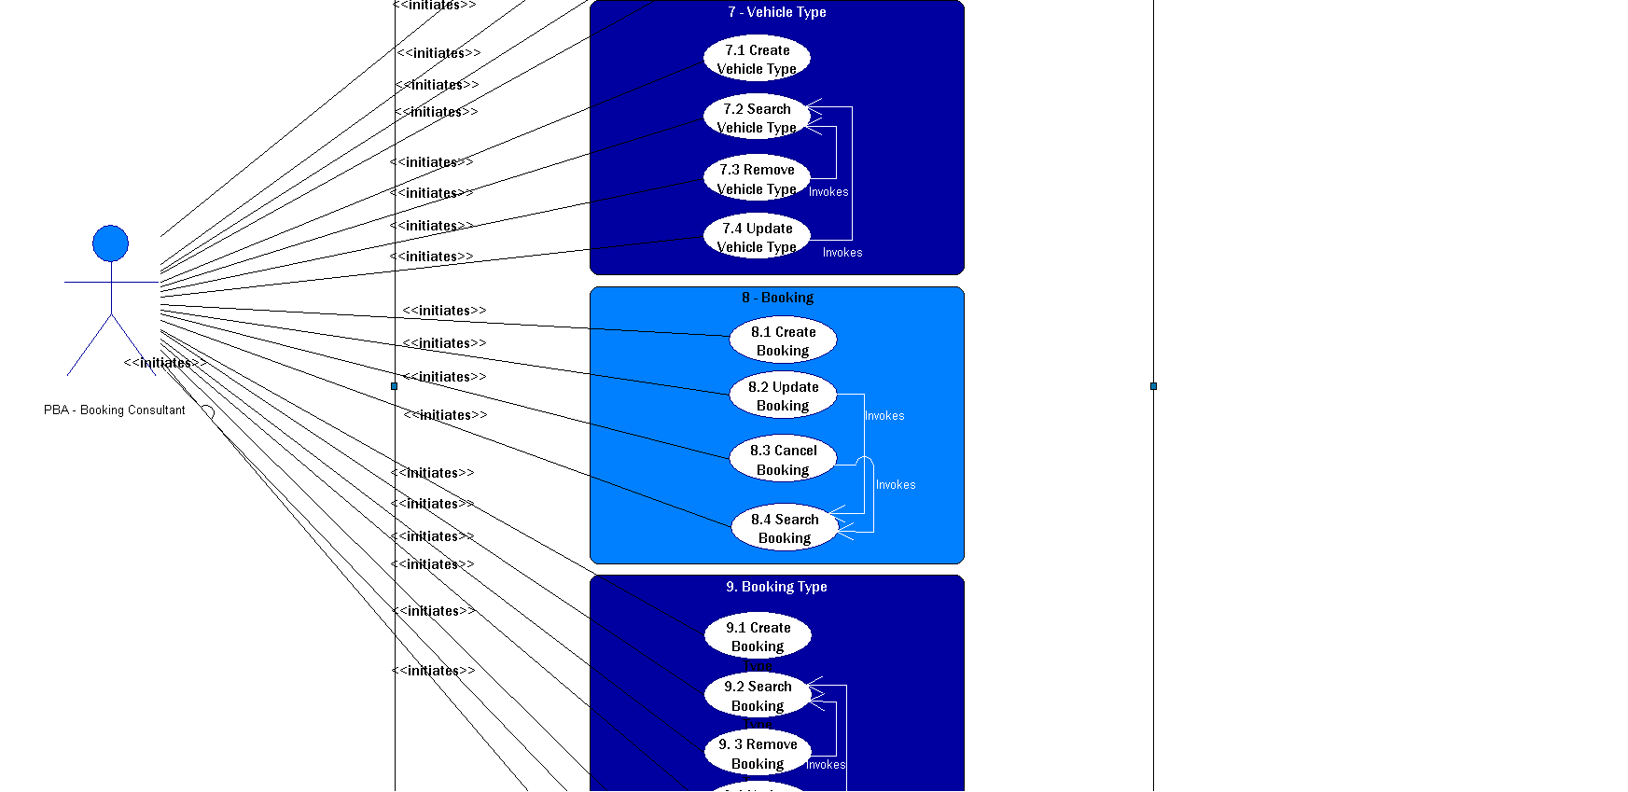

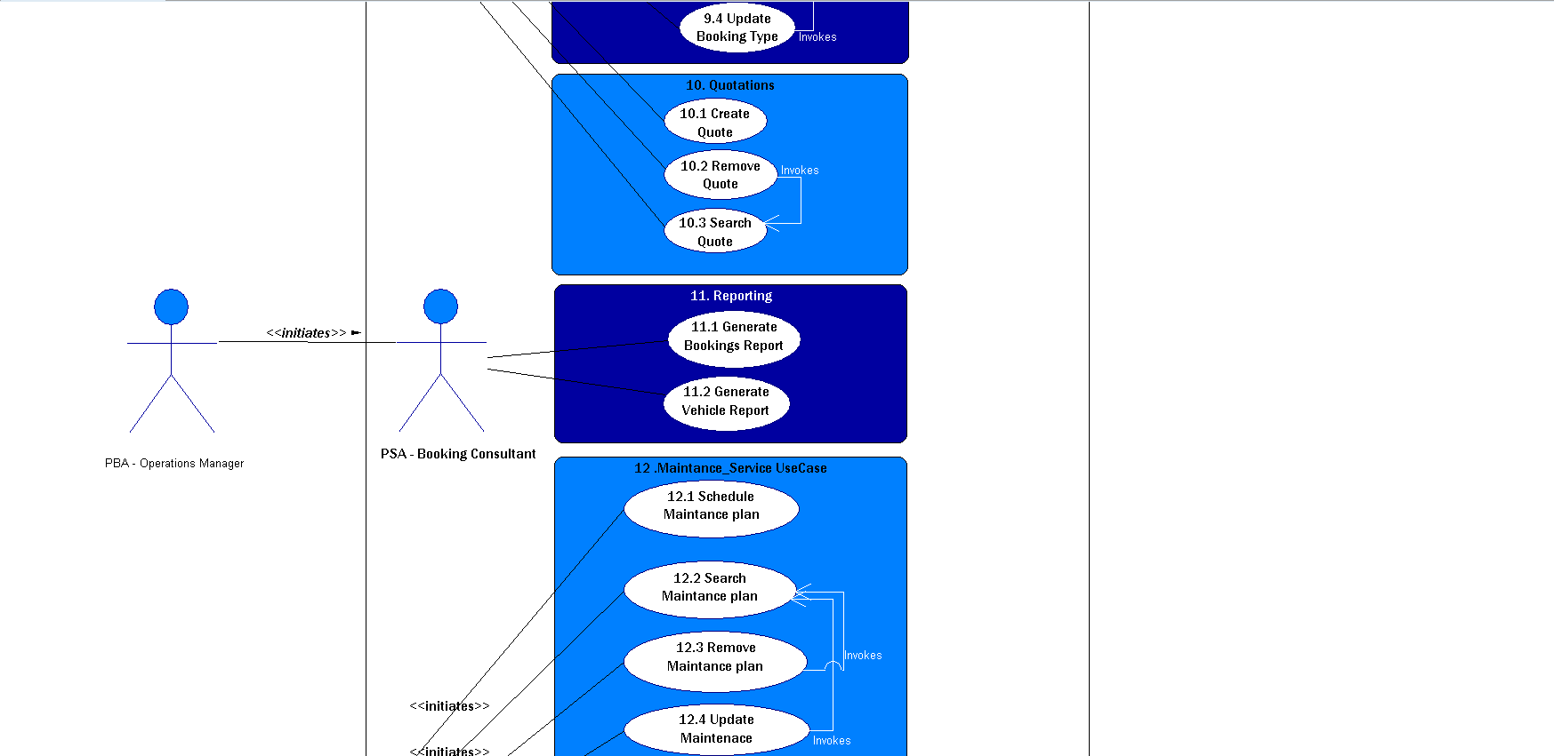

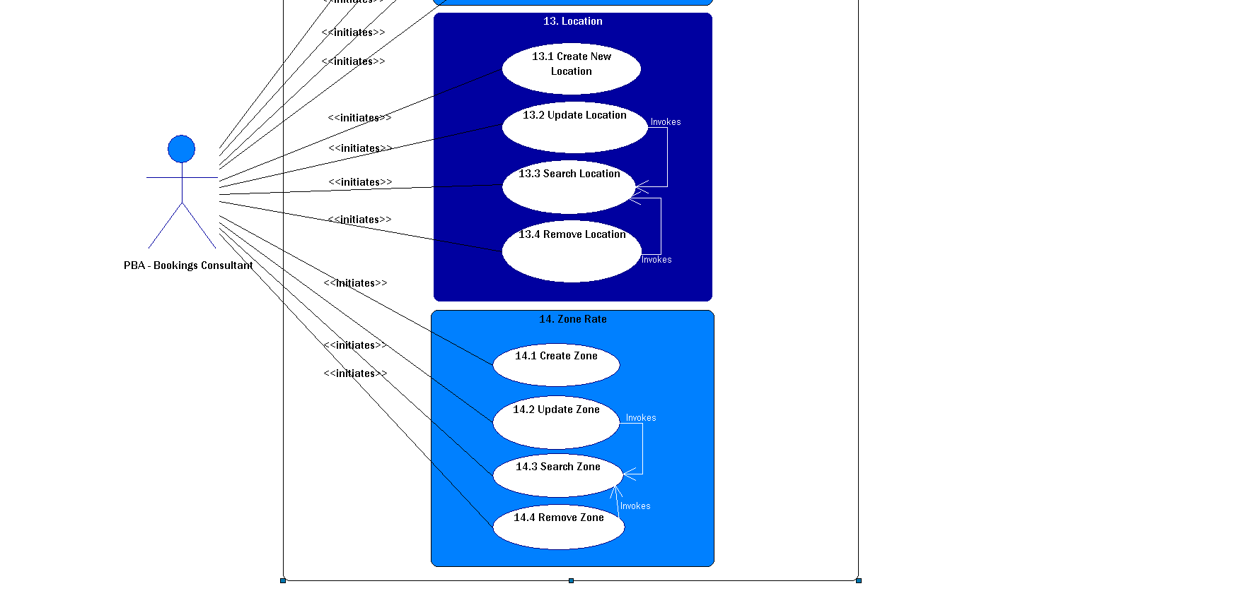

## conclusion

After reading this section the reader will have a clear and thorough understanding of what the business requirements within the organization are and how the client wants the system to function. A clear depiction of what the system does is provided which shows in-depth the abilities of the system

|  |
| --- |
| 7. DECISION ANALYSIS |



## 7.1 Introduction

**Purpose and background:**

The decision analysis process is a systematic and quantitative approach in business to evaluate important decisions faced by the business, such as the implementation of a system, which will ensure that the business is more efficient. Should the decision made be wrong, it would cost the business a lot of money thus a thorough analysis is necessary to ensure the business decision made is an informed and trusted one. The decision analysis process we use is the Feasibility analysis.

**Scope and structure:**

A feasibility analysis is used to measure how likely a project is to be completed. Information is collected from different candidates regarding the system they propose to be suitable for the business and the information is weighed against each other to determine which system is feasible following this criterion:

* **Operational** **feasibility:** This is used to determine whether the system will fulfill the requirements the user has and to what degree. The system should be a solution to the user’s current working environment and operational needs. Operational feasibility has the following factors:
* **Functionality**: Describes to what degree the system would benefit the organization and how well the system would work.
* **Political:** Describes how well received this system would be from user management, user, and organization perspective.
* **Technical feasibility**: This criterion is used to determine whether the system is technically practical meaning that it should be successfully designed and implemented in the business. This also analysis whether the users of the system have the technical expertise to use this system. Technical feasibility has the following factors:
* **Technology**: This is an assessment of the maturity, availability (or ability to acquire), and desirability of the computer technology needed to support this candidate.
* **Expertise**: This assesses the technical expertise needed to develop, operate, and maintain the candidate system.
* **Economic** **feasibility:** This is an evaluation of how much the business would have to pay for the system. The candidates must show whether their system is cost-effective or not and how much it would cost to maintain the system. This also covers how much the system chosen can make on the return on the investment and how long it will take using:
* Cost to develop
* Payback period (discounted)
* Net Present Value
* **Schedule feasibility:** This is to assess how long the system can be designed and implemented. The system created should be completed within an acceptable time for the business.

## 7.2.1 FEASIBILITY ANALYSIS

|  |  |  |  |  |
| --- | --- | --- | --- | --- |
| **Feasibility Criteria** | **Weight** | **Candidate 1** | **Candidate 2** | **Candidate 3** |
|  |  | Ecolane | Stillwater Express Solutions | C:\Users\MATHOPATONA PABALLO\Downloads\Picture1.jpg |
| **Operational Feasibility** | **30%** |  | |  |
| **Functionality**. A description of to what degree the candidate would benefit the organization and how well the system would work.  ‘ |  | * The system is a demand-response dispatch system therefore one can use the system at one’s leisure. * The system is also a scheduling dispatch system so clients can schedule rides when they need to. * It is an international software; the rates differ according to a country and have standard rates for their transportation. | Ride express is a scheduling software made for community service providers which includes van and volunteer driver rides, standing orders and vehicle maintenance.  Offers billing and invoicing services | * Siyaya Travel Assist is a booking and scheduling software system which is personalized for the operational needs of the client such as booking of vehicles, dispatch management, billing and invoicing as well as administrative services for transportation. |
| **Political**. A description of how well received this solution would be from user management, user, and organization perspective. |  | -The system was made in United States of America, although it also serves the international market, the currency and use of the Imperial system might be a problem for South African users.  **Score: 70** | Users of the system will be well impressed due to increasing efficiency and making documentation easy for them.  **Score: 65** | Improve efficiency and make the job easier for the Users  The automation of reporting system and communication will increase efficiency and productivity in the company  **Score: 85** |

|  |  |  |  |  |
| --- | --- | --- | --- | --- |
| **Technical Feasibility** | **30%** |  |  |  |

|  |  |  |  |  |
| --- | --- | --- | --- | --- |
| **Technology**. An assessment of the maturity, availability (or ability to acquire), and desirability of the computer technology needed to support this candidate. |  | - The deployment of the system offers Cloud, SaaS and Web deployment and mobile deployment available on Android Native as well as iOS Native  - The capability of producing various reports in compliance with contractual obligations and internal assessments on drivers on time performances, mapping capabilities allows for monitoring and tracking of trips and drivers.  - Needs integration of google maps API to track location and find the best/Shortest route to arrive at a specific location. | -Requires Microsoft Windows for deployment  -On the reservation screen you can only make 2 legs of a ride at a time.  -Require a proper and fast internet connection due to the use of servers to back up their client’s information. | -The system will automate transfer card and improve communication between drivers, clients, agencies through automated SMS and emails.  -The system will use web cams to send clients a picture of the driver collecting them.  -The drivers get an update earlier about the trips to avoid doing a back and forth.  -Mobile application for clients to rate our services and serves as a confirmation of arrival.  -Tracker system to keep track of the whereabouts of vehicles |
| **Expertise**. An assessment to the technical expertise needed to develop, operate, and maintain the candidate system. |  | -The system is easy to use but it requires a certain level of expertise because you might make errors which will affect the whole booking /trip  - The system is not an open source. In case of bugs the company will have to contact the provider to fix it.  -Yearly updates will be provided to the company but they must pay for them.  -The system is accommodated by training 24/7.  **Score: 70** | -Easier to use and the screen for drivers for scheduling consist of few screens which make it easy for the users to master it.  -The receptionist screen is not logical designed one might easily make a mistake on the system by pressing a wrong button; therefore, they should master the program to avoid such errors.  - Only the Software Providers can maintain the backend  -Training offered at business hours  **Score: 60** | -Not much of expertise will be needed due to the dialogue and informative screens.  -A manual and training will be used to improve the knowledge of the users about the debugging and functionality of the system  -A week of training for backend will be provided.  -Will use Visual Studio  develop our system with the integration of angular and SQL  Scripting.  -No training needed  **Score: 75** |
| **Economic Feasibility** | **30%** |  |  |  |
| **Cost to develop:** |  | N/A | R 101 576 | R 2 648.32 |
| **Payback period (discounted):** |  | N/A | N/A | Less than 2 months |
| **Net present value:** |  | N/A | N/A | R 122 317.21 |
|  |  | **Score: 60** | **Score: 75** | **Score: 93** |
| **Schedule Feasibility**  An assessment of how long the solution will take to design and implement. | **10%** |  |  |  |
|  | * The system will take 15 months to complete and one month to integrate   **Score: 75** | * The system will take 13 months to complete and one month to integrate   **Score: 80** | * The system should take nine months to complete and no integration time as the system is custom made.   **Score: 95** |

## 7.2.2 Details of each Alternatives

**Candidate 1:**

**Ecolane DRT**

**Operational**: Ecolane is a flexible, affordable and reliable choice for transit agencies which are looking for transit scheduling software. It is an easy to deploy system which works on demand-response scheduling. The service runs at regular intervals between drop-off and pick-up. This might be problematic for clients or passengers who need transport assistance at a specific time.

**Technical:** The system allows automated scheduling of trips, so passengers can book using a mobile app. The issue with advanced technology is accommodating users who are not technically equip.

**Economical:** The system works on standard American currency, as it is a US based, which might be problematic for the South African audience as the rates will be higher when the currency is converted. According to the economic feasibility calculation done it shows that the net value of the product is -R36 189.45, Meaning the company will be running at a loss therefore we reach conclusion that Ecolane is not feasible.

**Schedule:** The system is an already developed system which just needs to be deployed onto the devices which will take a month approximately.

*Table 4.1 Ecolane Feasibility*

|  |  |  |  |  |  |  |
| --- | --- | --- | --- | --- | --- | --- |
| Provision for year | Year 0 | Year 1 | Year 2 | | Year 3 | Total |
| Improvement of efficiency and control |  | R30 321 | R30 321 | | R30 321 | R90 963 |
| Discount Factor | 100% | 95.50% | 91% | | 86.50% |  |
| PV Total Benefits |  | R28 956.56 | R27 592.11 | | R26 227.67 | R82 776.34 |
|  |  | **Development Costs** | | |  |  |
| Billed Production Cost($/R) | R68 457.23 |  |  | |  |  |
| Online Training Costs (ANNUAL SUPPORT CONTRACT - 10 HRS) and Upgrades $/R |  | R8 663.94 | R8 663.94 | | R8 663.94 |  |
| Discount Factor | 100% | 95.50% | 91% | | 86.50% |  |
| PV Total Cost | R68 457.23 | R8 274.06 | R7 884.189 | | R7 494.31 | R92 109.79 |
|  |  | **Operating Costs** | | |  |  |
| Internet Access (Telkom Home Unlimited) | R7200 | R7200 | R7200 | | R7200 |  |
| Discount Factor | 100% | 95.50% | 91% | | 86.50% |  |
| PV Total Cost | R7200 | R6876 | R6 552 | | R6 228 | R26 856 |
|  |  | **Computations** | | |  |  |
| Total Benefits -Total Costs | (R75 657.23) | R14 457.06 | R14 457.06 | | R14 457.06 | (R32 286.05) |
| Net Cash Flow | (R51 067.45) | R45 321 | R45 321 | | R45 321 |  |
| Cumulative Cash Flow | (R51 067.45) | (R61 200.17) | | (R46 743.11) | (R32 286.05) |  |
| Net Present Value (PV Benefits- PV costs) |  |  |  | |  | (R36 189.45) |

**Candidate 2:** 

**Ride Express**

**Operational**: Ride Express is a powerful and affordable scheduling software for community transportation service providers. It was designed for small-to-medium sized provider of van, bus, and/or volunteer driver services. Private individual travelers are not exactly accommodated as this is mainly for community transportation.

**Technical:** The hardware needed for the system needs to have devices that have Microsoft Windows installed. Printer will need a printer that is Windows compatible.

**Schedule:** The system is already developed, and the deployment of the system will require approximately one month.

**Economical:** The price of the system is based on the version that one uses and the more people the system accommodates, the higher the price will be for the purchasing of the system. The system also needs a call center support system for the user support offered during business hours which is an annual expense. With the calculation made the Project is not feasible

|  |  |  |  |  |  |
| --- | --- | --- | --- | --- | --- |
| Provision for year | Year 0 | Year 1 | Year 2 | Year 3 | Total |
| Improvement of efficiency and control |  | R36 432 | R36 432 | R36 432 | R109 296 |
| Discount Factor | 100% | 95.50% | 91% | 86.50% |  |
| PV Total Benefits |  | R34 792.56 | R33 153.12 | R31 513.68 | R99 459.36 |
|  |  | **Development Costs** | |  |  |
| Billed Production Cost($/R) | R50 467.45 |  |  |  |  |
| Online Training Costs (ANNUAL SUPPORT CONTRACT - 10 HRS) and Upgrades $/R |  | R8 663.94 | R8 663.94 | R8 663.94 |  |
| Discount Factor | 100% | 95.50% | 91% | 86.50% |  |
| PV Total Cost | R51 067.45 | R8 274.06 | R7 884.189 | R7 494.31 | R74 720 |
|  |  | **Operating Costs** | |  |  |
| Internet Access (Telkom Home Unlimited) | R7200 | R7200 | R7200 | R7200 |  |
| Discount Factor | 100% | 95.50% | 91% | 86.50% |  |
| PV Total Cost | R7200 | R6876 | R6 552 | R6 228 | R26 856 |
|  |  | **Computations** | |  |  |
| Total Benefits -Total Costs | (R57 667.45) | R14 457.06 | R14 457.06 | R14 457.06 | (R7 696.27) |
| Net Cash Flow | (R51 067.45) | R45 321 | R45 321 | R45 321 |  |
| Cumulative Cash Flow | (R51 067.45) | (R36 610.39) | (R22 153.33) | (R7 696.27) |  |
| Net Present Value (PV Benefits- PV costs) |  |  |  |  | R18 799.66 |
|  |  |  |  |  |  |

*Table 5 Ride Express Feasibility*

**Candidate 3:**

**Siyaya Travel Assist**

‘

**Operational:** The system is specifically created for the client therefore the operations of the business will be well catered for according to the requirements of the client. The system offers booking assistance as well as reporting and scheduling services.

**Technical:** The system which will be developed has no physical device requirements from the user other than a working device. The system requires no further technical expertise other than basic computer literacy.

**Schedule:** The system will take 9 months complete and approximately a week to implement on the devices of the client.

**Economic:** After doing the economic feasible calculations the Siyaya Travel Assist resulted in a high net Present Value making it more feasible more than the other candidates.

|  |  |  |  |  |  |
| --- | --- | --- | --- | --- | --- |
| Provision for year | Year 0 | Year 1 | Year 2 | Year 3 | Total |
| Benefits |  | R62 325,21 | R62 325,21 | R62 325,21 | R186 975.63 |
| Improvement of Efficiency and operation |  | R62 325,21 | R62 325,21 | R62 325,21 |  |
| Discount Factor | 100% | 95.50% | 91% | 86.50% |  |
| PV Total Benefits |  | R59 520.58 | R56 715.94 | R53 911.30 | R170 147.83 |
|  |  | **Development Costs** | |  |  |
| Printing Documents | R2 236.32 | R0.00 | R0.00 | R0.0 |  |
| Files | R412.00 |  |  |  |  |
| WI-FI | R0.0 |  |  |  |  |
| Total Development Costs |  |  |  |  | R2 648.32 |
|  |  | **Operating Costs** | |  |  |
| Operation & maintenance cost (15% annual increase) | R0.0 | R5 623.22 | R5 623.22 | R5 623.22 |  |
| Internet Access (Telkom Home Unlimited) | R7200 | R7200 | R7200 | R7200 |  |
| Discount Factor | 100% | 95.50% | 91% | 86.50% |  |
| PV Total Cost | R9 848.32 | R12 246.18 | R11 669.13 | R11 092.09 | R47 830.62 |
| Total Costs | R9 848.32 | R12 823.22 | R12 823.22 | R12 823.22 |  |
|  |  | **Computations** | |  |  |
| Total Benefits- Total Costs | (R9 848.32) | R46 697.36 | R46 697.36 | R46 697.36 | R130 243.76 |
| Net Cashflow | (R9 848.32) | R62 325,21 | R62 325,21 | R62 325,21 |  |
| Cumulative Cash Flow | (R9 848.32) | R36 849.04 | R83 546.40 | R130243.76 |  |
| Net Present Value (PV Benefits- PV Costs) |  |  |  |  | R122 317.21 |

*Table 6 Siyaya Travel Assist Feasibility*

## 7.2 RECOMMENDATIONS

**Siyaya Travel Assist** is a system which will be specifically created for the client which means that every client requirement, from the booking of the vehicles to the reports which will be generated, is catered exactly for the client. It requires no training from the staff or the business therefore the system can be used immediately as soon it has been integrated. The users should be quite comfortable working with the system as it was created for their daily operations.

The system costs are mainly constituted to the documentation leading up to the development of the system. No licensing fees will be required for the system thus making it a cost-effective solution as compared to the other candidates.

The system is yet to be developed making it a schedule problem, but the integration of the system is one the promises to be a smooth one.

**Siyaya Travel Assist** will be a more effective and more efficient solution.

## conclusion

In this section a feasibility analysis of three candidates which our client could implement and use for their daily operations. Each candidate was assessed in terms of their operational, technical, economic and schedule feasibility. A detailed recommendation was given looking at the feasibility analysis.

|  |
| --- |
| 8. APPENDIX A: CLIENT DOCUMENTATION |



## Introduction

This section will display all the current documentation and system functionality that Ndila Transfers currently uses and employs. This section will help us better understand what need to be improved on and automated to help eliminate paper work and manual data capturing.

## 8.1 Documents

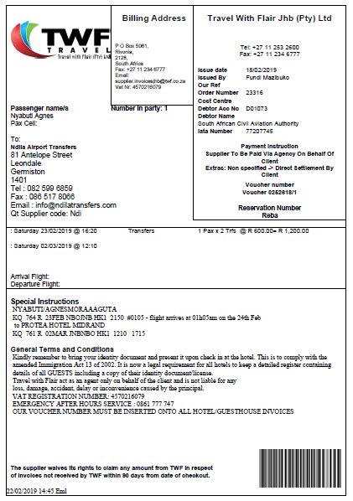













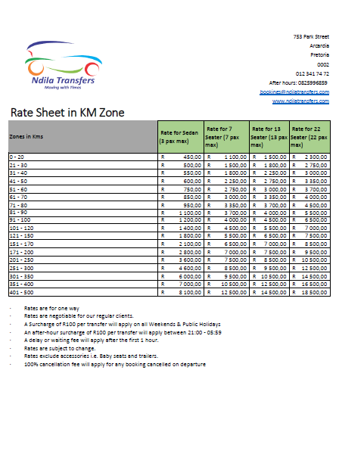





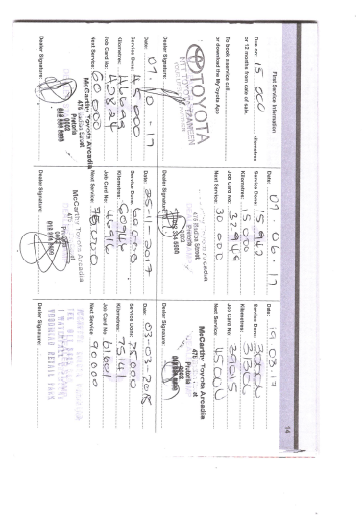

## conclusion

After reading this section a clear and thorough understanding of what the client documentation looks like will be identified. This will show the different types of outputs and inputs into the system as well as when and where these inputs or/and outputs are generated and used.

|  |
| --- |
| 9. APPENDIX B: OTHER SYSTEMS INVESTIGATED |



## Introduction

For this sections research has be conducted about other systems like the proposed system. We look at this systems functionality, the design and compare it with the proposed system for Ndila Transfers. A clear understanding of other systems in the business environment will be given. These systems can be implemented generally in the same type of business environment; however, our proposed system will be customized to the client’s needs and specifications ensuring that the optimal system will be delivered to the client.

## 9.1 LITERATURE STUDY

**Ecolane**



**About**

Ecolane is a well-known company for transportation in the USA and Internationally can cater to a lot of routes around the globe. According to their website, Ecolane allows drivers to focus on providing reliable, efficient service while leaving the complex logistics of demand-responsive software and fixed route transit systems to modern, intelligent tools that make a real difference in an agency's operations.

At the administrative level, Ecolane’s software provides tools and services to manage, monitor and assess the system and employee performance in real-time.

**Ecolane Main Features:**

* Real-time reporting & analytics
* Automated real-time scheduling & dispatching
* Comprehensive planning, training, and support
* An intelligent fleet management system
* Customization based on specific agency needs and preferences

**Pricing**

Not provided by vendor, however, one can schedule a free demo with Ecolane.

**Average Ratings**

|  |  |
| --- | --- |
| Overall | 4.5 / 5 |
| Ease of Use | 4 / 5 |
| Customer Service | 4.5 / 5 |

**Product Details**

|  |  |
| --- | --- |
| Starting Price | Not provided by vendor |
| Deployment | Cloud, SaaS, Web Mobile - Android Native Mobile - iOS Native |
| Training | Documentation Webinars Live Online In Person |
| Support | Online Business Hours 24/7 (Live Rep |

**Vendor Details**

Ecolane

www.ecolane.com/

Founded 2002

United States

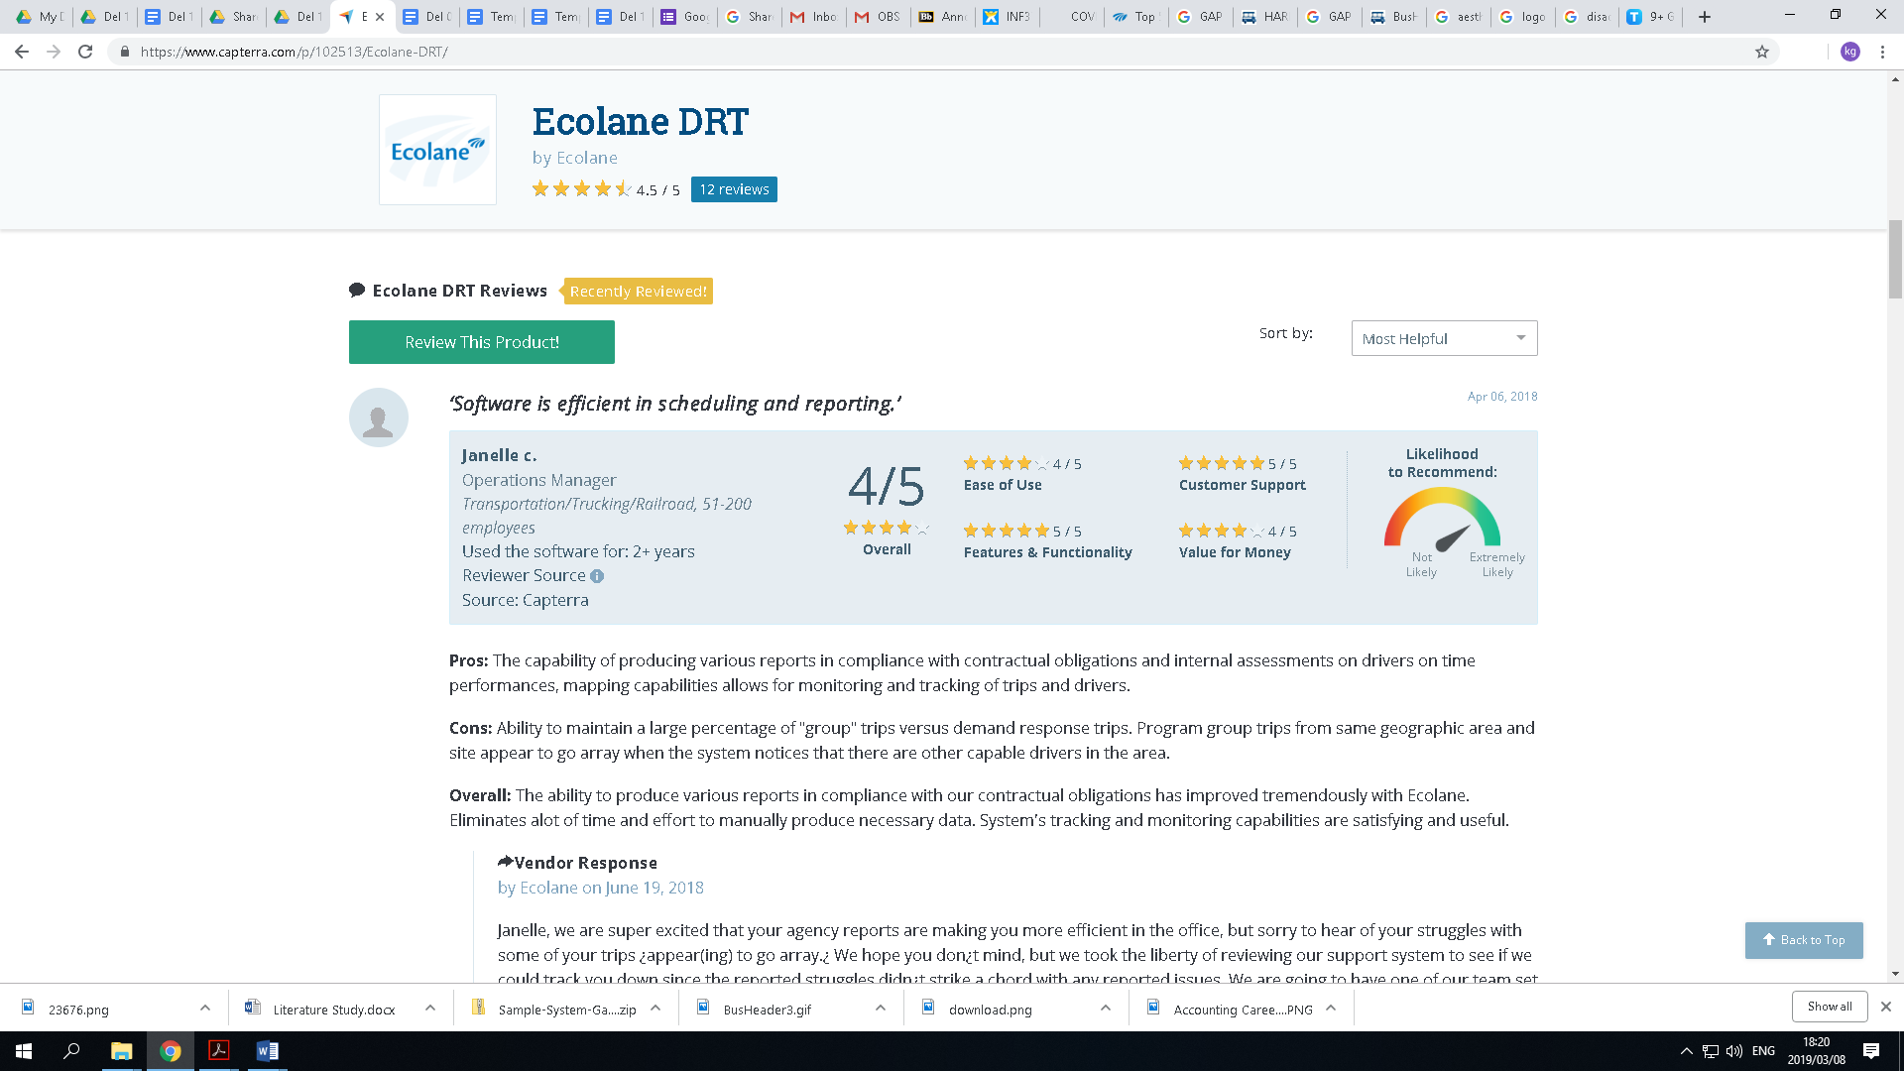

Mountain with Flag on Top Icon

**RELIABLE SOLUTIONS BACKED BY RELIABLE PEOPLE**

Ecolane's products are solid, reliable, and field proven, but the solution benefits can be attributed to more than just the software. Offering a comprehensive support package and a dedicated team of experts, Ecolane ensures that the transition to our platform is smooth, effective, and delivers the intended results.

**INNOVATION DRIVEN BY PASSION**

Ecolane is made up of a team of professionals who all share a single vision; driving the transit industry to the next level. Striving to maintain our standing as a thought-leader within the industry, our team is constantly exploring and developing new ways of leveraging technology to support the needs and goals of our clients. We take pride in our position as the leading innovator in our field.

**TRUSTED CUSTOMER RELATIONS**

With the belief that great partnerships stem from great relationships, Ecolane works to build a foundation of trust and accountability with every client we serve. Strong relationships are the backbone of our business, and our goal is to create an environment that promotes input and collaboration from our partners so that we can continue to improve upon the quality of our products and services.

See what other small and medium-sized agencies are doing today.

 Ecolane is widely used and making a significant and positive impact for transit agencies across North America. Take a moment and review the examples below to see how agencies like yours are embracing Ecolane's industry-leading solutions and improving transit for their riders while also positively impacting their bottom line.

**INTELLIGENT DEMAND-RESPONSE MANAGEMENT SOFTWARE**

Scheduling and dispatching headaches used to be the rule, not the exception. Ecolane's DRT platform has made them obsolete with a turn-key, secure, web-based software package, easily and quickly accessed via modern web browsers. The DRT platform allows for schedule optimizations in real-time, and provides multiple operational advantages to small and medium transit agencies, including:

|  |  |
| --- | --- |
| Industry-Leading Trip Booking and Reservation Management System | Rider and Customer Experience Extensions |
| Fleet Management and Safety Features | Intelligent Operations Management |
| Financial Operations Management | Broker / Provider Integration |
| Professional Support and Services | System Security Management |

**ECOLANE'S MOBILE APP**

* Riding with us just keeps getting better.
* We now have an innovative mobile app which is fully integrated with our signature Demand-Response Software.
* Passengers will gain three convenient benefits:
* Flexibility to Manage Trips
* Convenient Trip Details View
* Simple, User-friendly Mobile Interface
* Our agency partners will also benefit by:
* Streamlined Scheduling Operations
* Decreased Trip Losses
* Customized Offerings

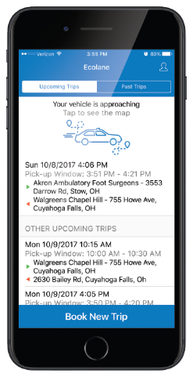

**BENEFITS OF OUR MOBILE APP FOR RIDERS**

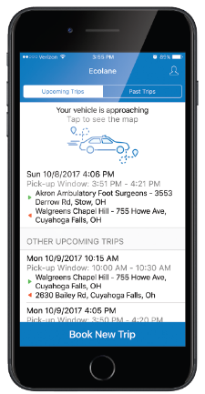

Flexibility to manage trips in today's world, providing riders with direct access to review and manage their transportation needs is essential. Users of Ecolane's mobile app can view both upcoming and completed trips, while also having the ability to cancel travel if they no longer wish to ride.

Convenient trip details view Built-in phone notifications alert riders with vehicle ETAs, reducing wait time and providing a significantly more positive experience. When a vehicle is on its way, riders can track the journey using a visual map.

Simplified mobile interface Trip planning has never been an easier experience for riders than with Ecolane's mobile app. 24/7 access to account profiles, reservations and travel history with a single tap, all connected to the most powerful, industry-leading scheduling and dispatch platform available.

Text to “Speech Robocalls” were great, five years ago. Utilizing the text-to-speech capabilities native to today's smart phones is cheaper, easier and provides an all-around better experience for your riders.

BENEFITS OF OUR MOBILE APP FOR CUSTOMERS

Streamlined scheduling operations by providing riders with the opportunity to book their trips directly through the app at any time of day, even outside of business hours, the volume of incoming calls is significantly reduced. The mobile app is fully integrated with Ecolane’s DRT platform and provides all the power of real-time scheduling and continuous optimization inside the convenience of a mobile phone. No manual scheduling is required by dispatch.

Decreased trip loss  
Automatic push notifications remind riders of scheduled/upcoming trips, significantly reducing no-shows and same-day cancellations.

**THE DEMAND RESPONSE MANAGEMENT SOFTWARE THE INDUSTRY** **HAS BEEN LOOKING FOR**

Scheduling and dispatching headaches used to be commonplace. Ecolane's DRT platform has made them obsolete with a turn-key, web-based software package, securely accessed via modern web browsers. The DRT platform provides real-time, logic-based schedule optimization, providing transit operations of all sizes with several critical advantages, including:

**LEARN MORE**

The Ecolane demand-responsive transportation (DRT) software makes scheduling and booking trips easy and seamless.  Our cloud-based system enables your riders to schedule trips by phone, user portal, or even via our [mobile app](https://www.ecolane.com/mobile-app-demo).  Once a trip is scheduled, it is automatically fit into the manifest, including trips scheduled on the day of service.  Reservationists, dispatchers, and drivers can view the update instantaneously.

Group trips and batching functionality enable riders to specify the number of people taking a trip, so the driver will always know if they are picking up one person or more when it appears on the vehicles mobile data tablet (MDT).

**LEARN MORE**

Ecolane delivers your riders a world-class user experience by ensuring they not only have mobility and independence, but that they have control of their own schedules.  We offer rider-facing tools such as a self-service portal they can access directly online, [a mobile app](https://www.ecolane.com/mobile-app-demo), and even a skill for Alexa devices that utilize interactive voice response (IVR) to enable self-bookings. This allows riders the freedom to use the methods they're most comfortable with, thereby improving their customer satisfaction.

Agencies also benefit from these user-friendly options. Avoiding being inundated with phone calls from riders to book trips or to simply check the status of their vehicles saves a great deal of time.  It allows schedulers and dispatchers to focus on broader issues while customers enjoy the ease and convenience of getting answers without extended time on the phone (and possibly missing their pick-ups).  Using GPS technology, riders can see the location of their vehicles on the app up to the moment of arrival. They also can receive arrival notifications on their phones when the vehicle is approaching the pick-up location.

Ecolane's demand-responsive transportation (DRT) solution employs automatic vehicle location (AVL) technology via GPS.  Schedulers and dispatchers can track and monitor any vehicle within their fleet in real-time and see a comprehensive list of data, such as: Vehicle location

Where a vehicle is headed If a driver needs to change course to accommodate a same-day trip, cancellation, or no-show What time a driver picked up and dropped off a rider

The [mobile data tablet](https://www.ecolane.com/solutions/mdt-software) (MDT) makes it easy and seamless for drivers to adjust to changes in the day.  In addition, Ecolane offers premier [pre and post-trip vehicle inspection](https://www.ecolane.com/pre-post-inspection) software that measure the internal and external conditions of a vehicle, operated by the driver and run on the MDT before departure for the day and after the vehicle is shut down for the night.  The performance measurements align with municipal, state, and federal requirements, and agencies can get deeper insights into the vehicles' conditions over and above those requirements.  The software is customizable, so agencies can require other items to pass inspection prior to departure or shutdown.  This commitment to safety is one more way Ecolane and its agency customers place people first.

Signature Capture via MDT

Ecolane's DRT platform handle the scheduling and dispatching of trips and pass them off to [mobile data tablets](https://www.ecolane.com/solutions/mdt-software) (MDTs) installed in vehicles.  The solution provides real-time information updates to drivers including same-day schedule changes due to trip cancellations, no-shows, or even traffic congestion.  The result is maximized efficiency and optimized productivity in the agency’s use of their resources.

With the automated DRT solution, transit agency employees can focus their efforts on service monitoring and proactive problem solving to provide the highest quality of service for their riders.  Continuous, real-time data collection from the MDTs also enable accurate reporting and billing reviews at any time.

Additionally, the web-based user interface provides agencies with comprehensive information regarding their service as well as the tools needed to effectively manage and monitor their operations.

Ecolane's demand-responsive transportation (DRT) software does much more than automated scheduling. It also has a configurable billing module for calculating trip fares, transportation provider costs, and funding source costs.  It will calculate these costs seamlessly, so there is no manual work done by the agency or by the rider.

At the time a rider schedules a trip, the system will automatically calculate the rider fare based on the location, distance to the destination, and number of riders.  The charge is then applied upon actual boarding.  Since this is all performed automatically on the back-end, the agency can concentrate on optimizing their operations and servicing as many riders per day as possible while not having to worry about payment collection.   The system also has compliance and auditing functions in place to ensure that full payment is applied, as every ride scheduled has its unique set of charges depending on the nature of the trip and the number of passengers.

Brokers and coordinators could manage large fleets composed of many different providers and then track those vehicles in real-time. Brokers can choose to have the system assign trips based on the least-cost provider and providers can access a portal to accept and reject trips, make dispatch adjustments in real-time, and report essential changes.

Ecolane's brokerage solution builds upon the flexibility of the coordinator model while also integrating features designed to meet the complex billing needs of brokers.  With this solution, brokers can blend their business seamlessly with additional provider contracts to achieve a truly centralized call intake and scheduling environment.

Ecolane's professional services and implementation team conduct thorough agency audits and assess areas for optimization, specific to the way your organization is run.  By reviewing performance metrics, Ecolane can identify areas for improvement and enhancement. At that point, our team will configure and customize your demand-responsive transportation (DRT) system.

Our professional services team is dedicated to ensuring a thorough understanding of the DRT system prior to your agency going live. We don't "implement and leave" without ensuring your comfort with the system. Even after training is complete and your implementation is live, Ecolane's support is continually available to answer any questions.  We also perform annual reviews and performance operations audits, as needed, to ensure our customers are getting the very most out of their implementations. This is a differentiator for Ecolane in the way we work and our belief in the critical role our product plays in a customer's operations.

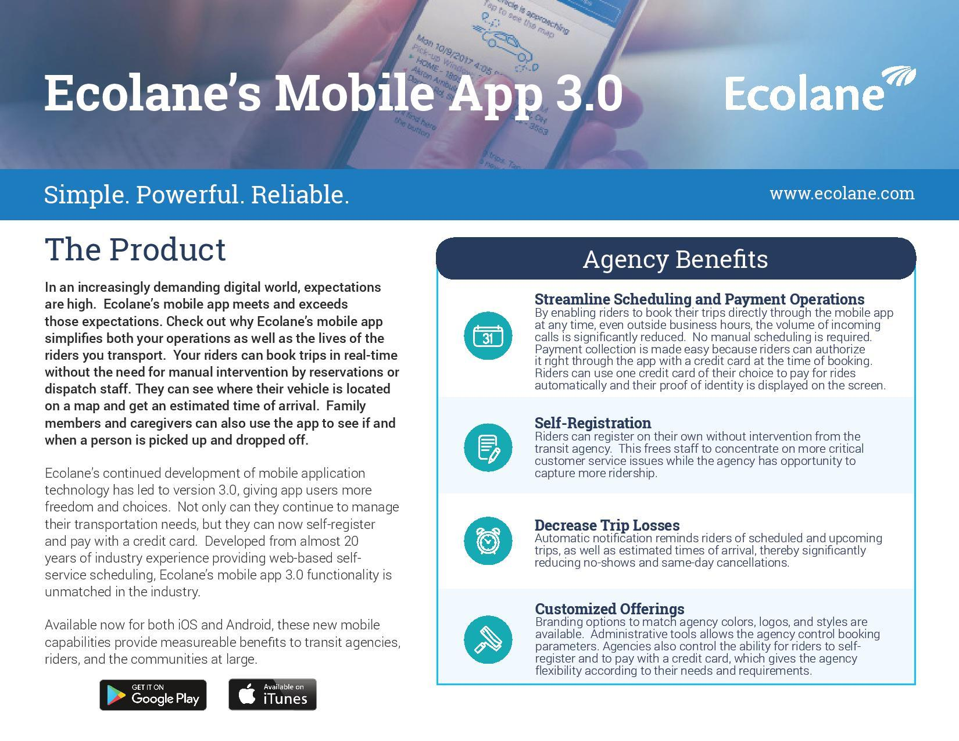MORE

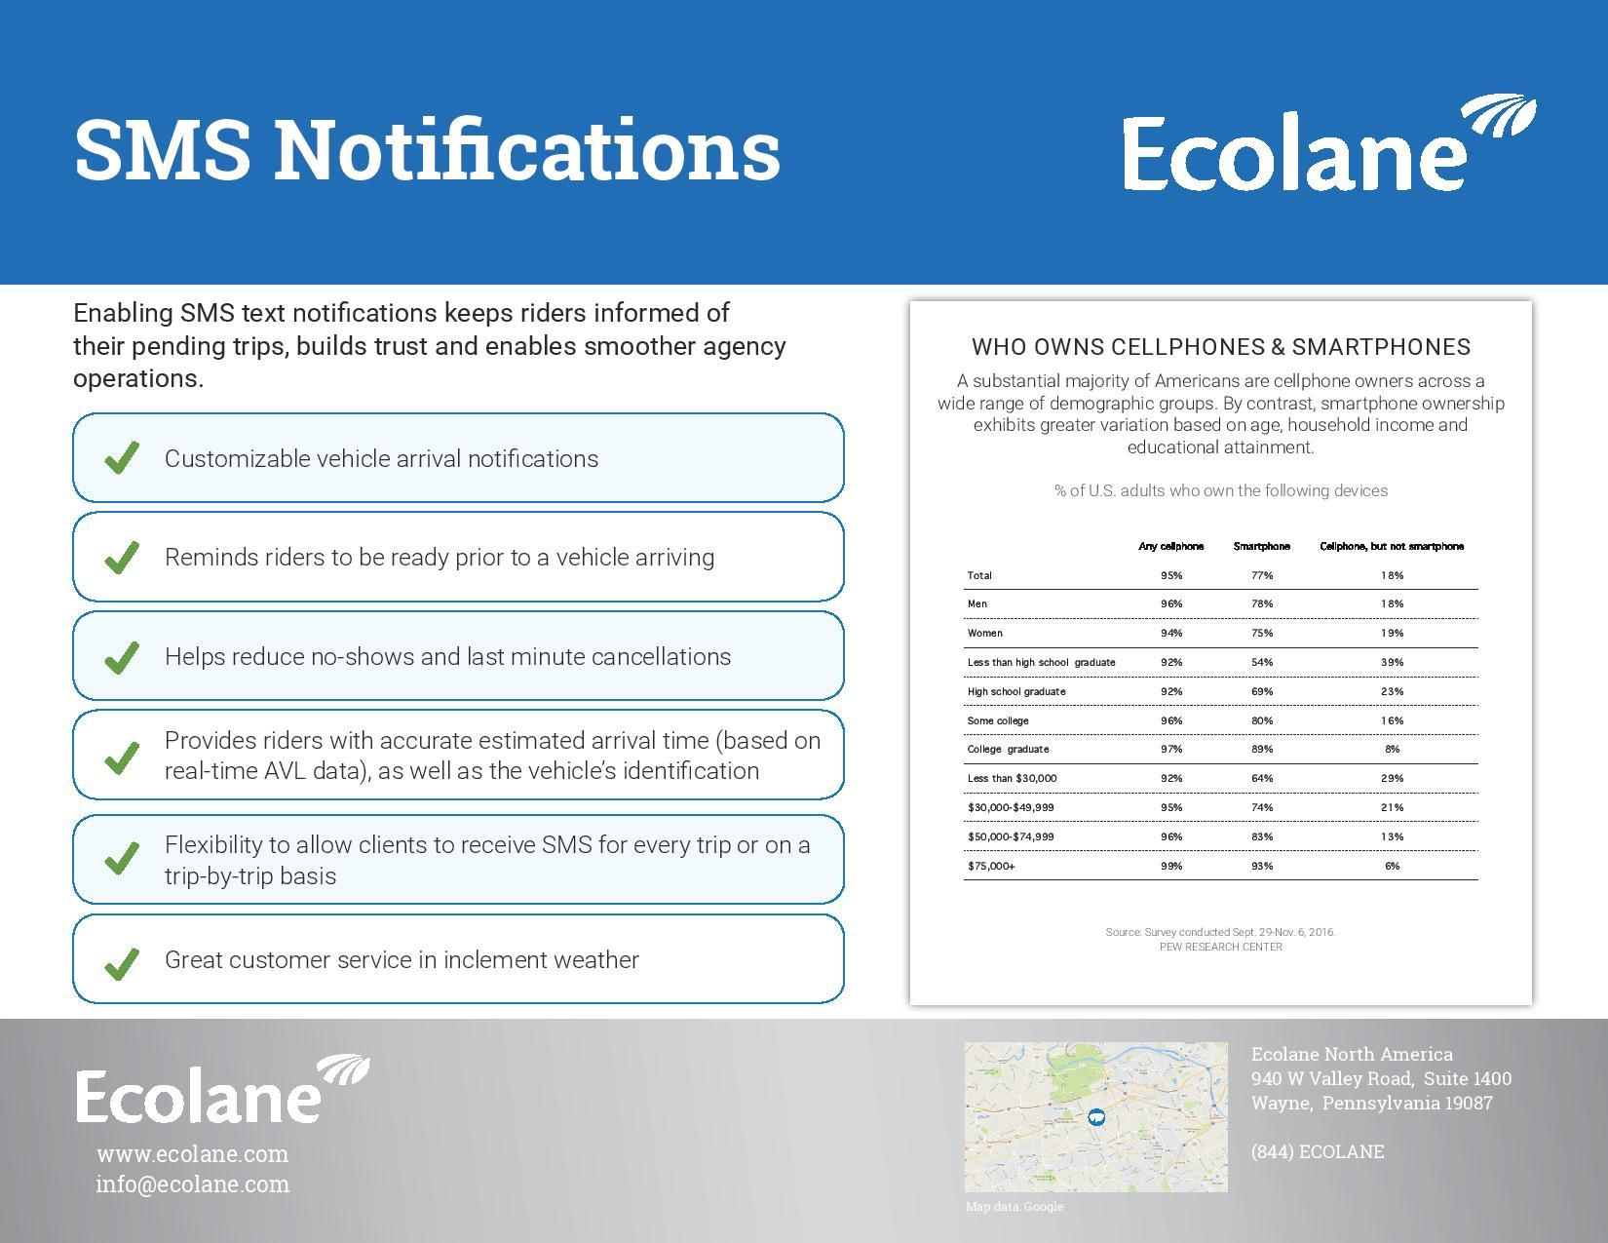

References:

<https://www.ecolane.com/> [Visited on: 2019-03-04]

<https://www.capterra.com/p/102513/Ecolane-DRT/> [Visited on: 2019-03-04]

**Ride Express**



**About**

Ride Express is Powerful and affordable scheduling software for community transportation service providers. Includes van and volunteer driver rides, standing orders, route maps and optimization, driver logs with passenger needs, demographics, billing, 5310 statistics, driver training/background, vehicle maintenance, many standard reports, and DIY Query tool.

**Ride Express Main Features:**

* Reservations with quick-entry addresses and return trips.
* Companion/attendant rides.
* Standing orders.
* Capacity monitor showing available space on bus or van.
* Rider special needs tracking.
* Unlimited ride types.
* Payer contracts by ride type.
* Driver logs and schedules.
* Driver certification tracking and reminders.
* Vehicle maintenance records.
* Route maps.
* Reports for billing, rider statistics, 5310 data, driver reimbursement.
* Do-it-yourself query and reporting tool.

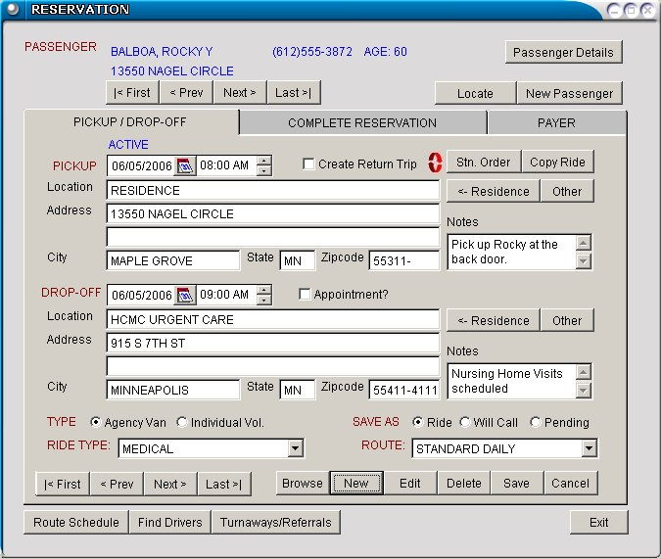

**Average Ratings:**

|  |  |
| --- | --- |
| Overall | 4.5 / 5 |
| Ease of Use | 4.5 / 5 |
| Customer Service | 5/5 |

**Product Details:**

|  |  |
| --- | --- |
| Starting Price | $3,495.00/one-time |
| Free Demo | Yes |
| Deployment | Installed - Windows |
| Training | Documentation Live Online In Person |
| Support | Business Hours |

Vendor Details

Stillwater Express Solutions

www.rideexpress.com/

Founded 1999

United States

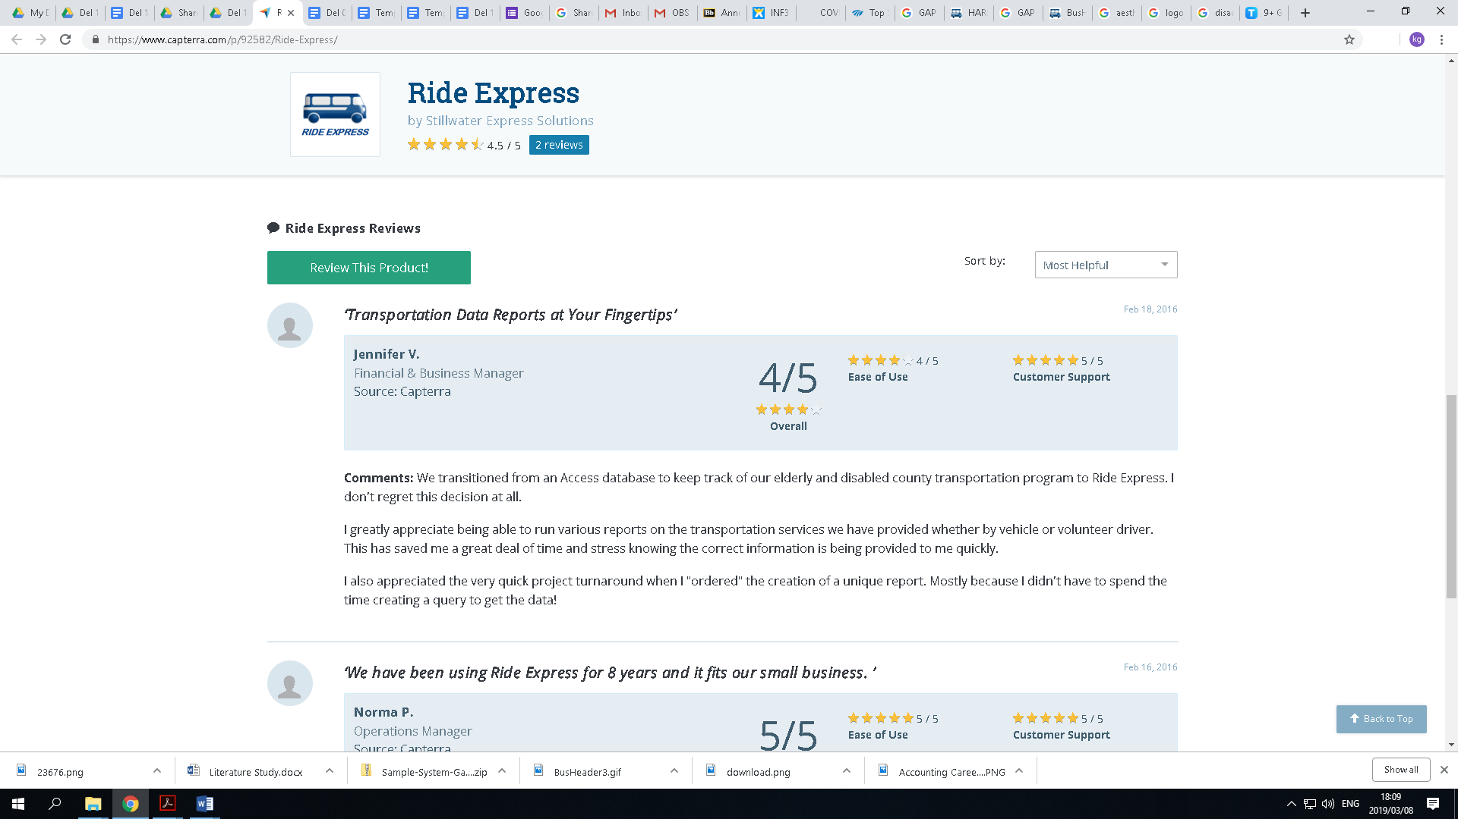

Pricing

|  |  |
| --- | --- |
| STAND ALONE VERSION | |
| Single-User Version | $3,995 |
| Five-User Network Version | $4,995 |

|  |  |
| --- | --- |
| ADD TO YOUR SENIORS EXPRESS SYSTEM | |
| Single and Multiple User Versions | $3,495 |

|  |  |
| --- | --- |
| ANNUAL SUPPORT CONTRACT - 10 HRS. PHONE SUPPORT PLUS UPGRADES | |
| Single-User | $250 |
| Multiple Users | $600 |

|  |  |  |  |  |  |  |  |  |  |  |  |  |  |  |  |  |  |  |  |
| --- | --- | --- | --- | --- | --- | --- | --- | --- | --- | --- | --- | --- | --- | --- | --- | --- | --- | --- | --- |
|  | Hardware requirements   |  |  | | --- | --- | | PC Workstation | Recommended Requirements | | CPU | Windows 7/10 (32/64 bit) 2 GHz Windows XP 1 GHz | | RAM Memory | Windows 7/10 (32/64 bit) 4 GB Windows XP 512 MB | | Available Hard Drive Space | 2 GB | | Operating System | Windows 7/10 (32/64 bit), Windows XP (SP3) | | Monitor | Super VGA (800 x 600) or higher resolution with 256 Color | | Mouse | Windows compatible pointing device | | CD/DVD Rom Drive | 16X Speed | | Printer | Any Windows compatible printer that supports graphics.  Color required for color printing of maps. | |
|  |

|  |
| --- |
|  |
| |  |  | | --- | --- | | Local Terminal Server | Recommended Requirements | | CPU | 3 GHz | | RAM Memory | 16 GB | | Available Hard Drive Space | 2 GB for Database | | Operating System | Windows Server 2008 R2 or newer with Terminal Services (Citrix Server with above hardware is suitable) | | Terminal Server Licenses | 5 user licenses | |

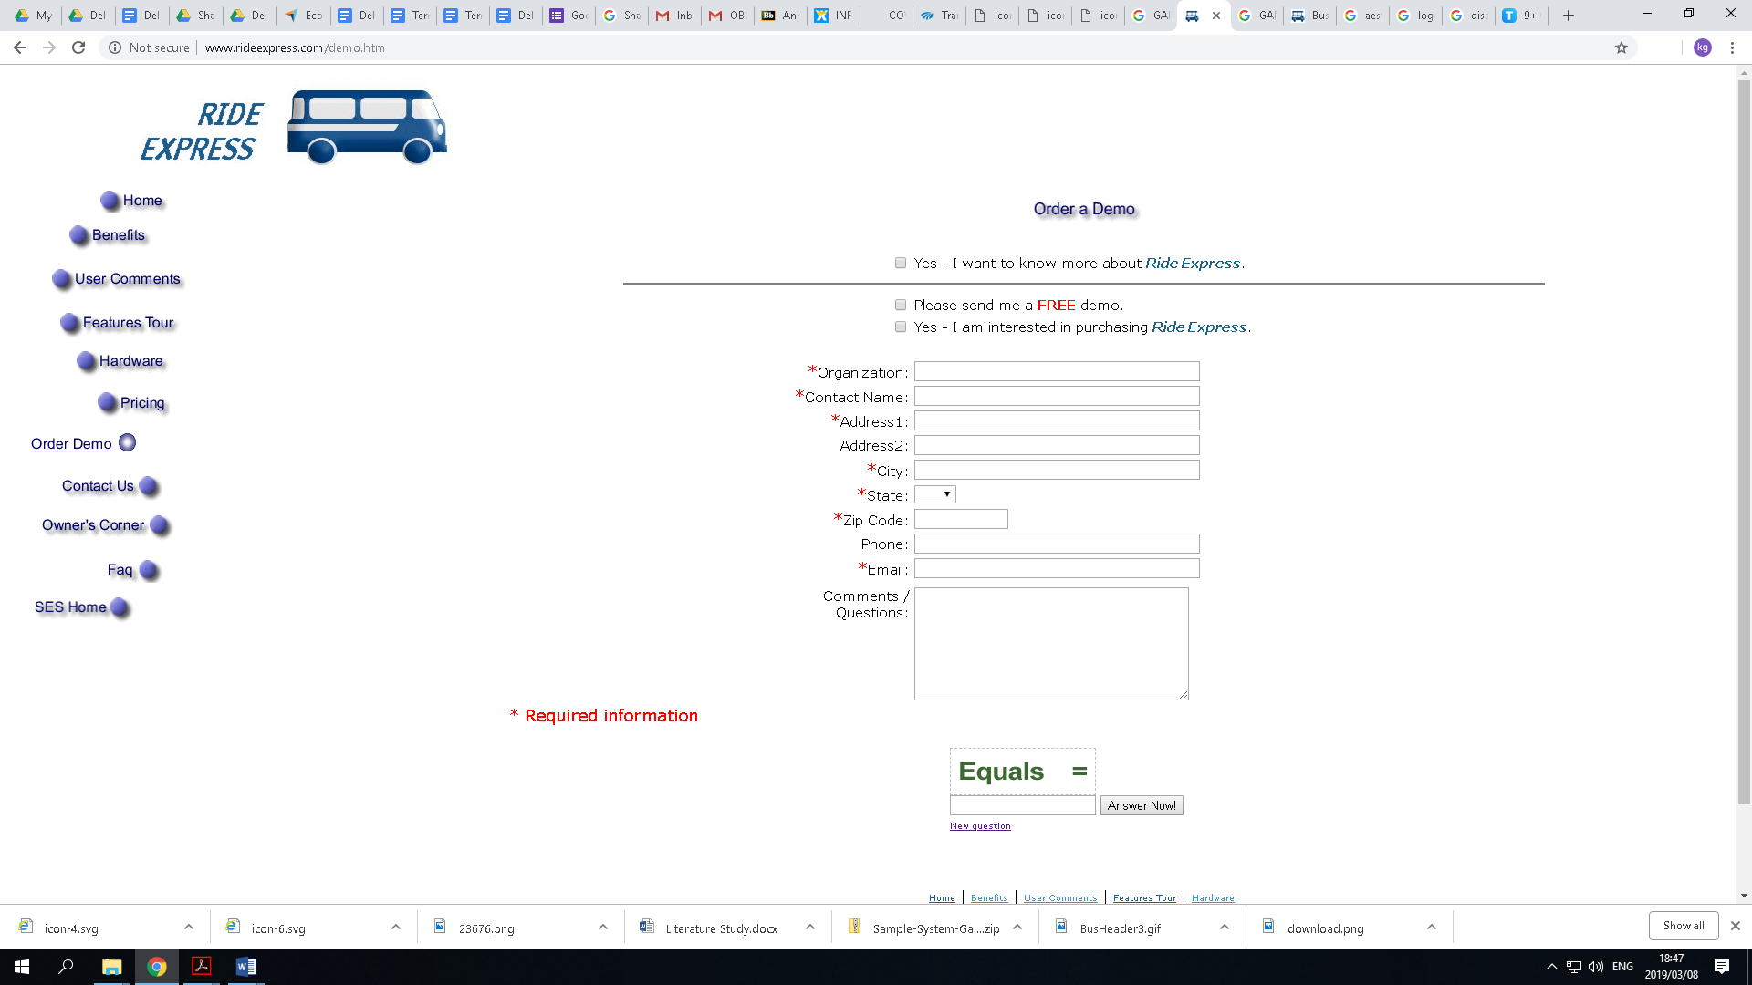

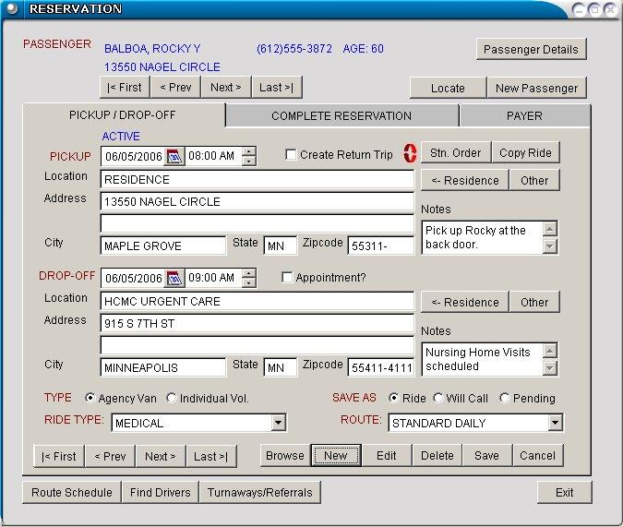

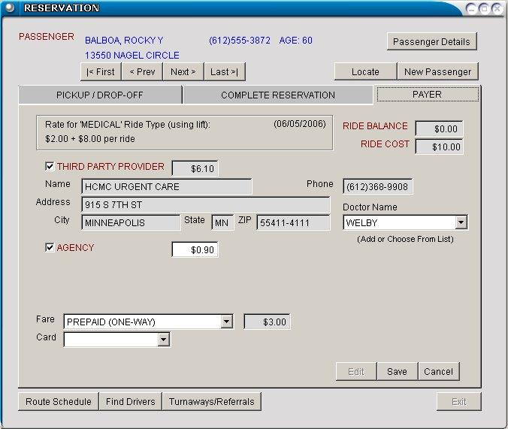

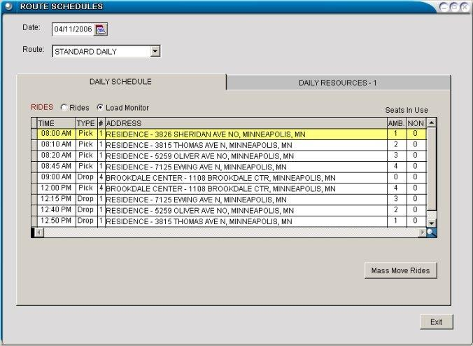

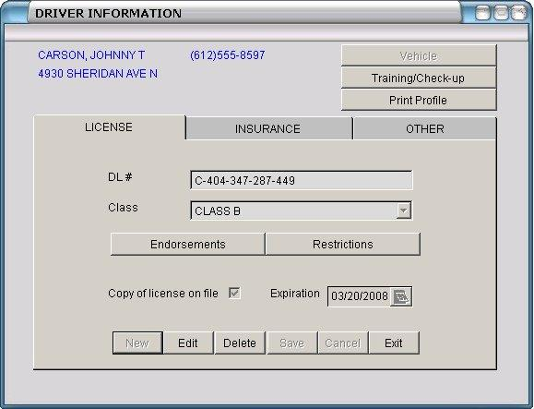

VEHICLES

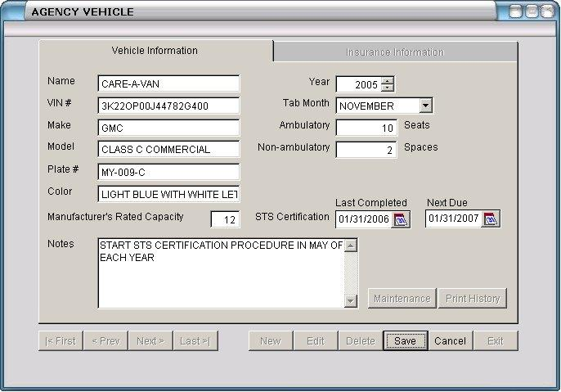

**References:**

<https://www.capterra.com/p/92582/Ride-Express/> [Visited on: 2019-03-04]

<http://www.rideexpress.com/> [Visited on: 2019-03-04]

## 9.2 GAP ANALYSIS REPORT



9.2.1) **Ecolane system (Alternative 1)**

Ecolane is a well-known company for transportation in the USA and Internationally can cater for a lot of routes around the globe

They don’t cater for individual transportation of clients and document

|  |  |
| --- | --- |
| Advantage’s | Disadvantage’s |
| Data Communication in Real-Time | Managers may not immediately understand how a new route scheduling software works |
| Tracking Driver Behaviour | an unexpected change in delivery creates distrust and, in some cases, real hardship for the system |
| Schedule Optimization and Increased Productivity | Uses terminologies that are not found in any of the official South Africa languages, thus requires terminology research before usage |
| Real-Time Vehicle Location | System is not user friendly as the system is poorly developed, there are many graphical errors |
| Faster and More Efficient Dispatching | System comes with a huge amount of set default data that is irrelevant to our Client |



9.2.2) **Ride Express (Alternative 2)**

Ride express is a community software. Is designed for different companies. So, it is fully registered and a trust worthy company.

|  |  |
| --- | --- |
| Advantage’s | Disadvantage’s |
| Expedite reservations and other dispatch activities. | The system is poorly developed according to our Client as it lacks many key functionalities that our client wants. |
| Support drivers as they assist passengers, collect fares, and manage routes. | Fixed Schedules, compared to cars that provide the maximum flexibility, this system does not |
| Speed up billing and other activity reporting. | System is not user friendly as the system has poorly developed aesthetic on the system, there are many graphical errors |
| Empower management with information about demographics, demand, volume, performance, volunteer activity, equipment | data from old customers who no longer travel exist as they delete records to save space |



|  |  |
| --- | --- |
| Advantage’s | Disadvantage’s |
| The system has no development or initial hidden costs for the Client than buying off-the-shelf | First generation software is usually immature |
| Requires no internet connection as well be using a 3rd party API to send confirmation emails | May contain a fair amount of software defects - usual for newly developed software |
| Speed up billing and other activity reporting. |  |
| Interface is use friendly and does not need any computer Literature to understand the working flow |  |
| The system is easily accessible for most platforms, Pac, Mac etc. |  |
| The system is customised with functionalities that sets out exactly what the client wants |  |

9.2.3) SiyayaTravelAssist (proposed solution)

The system (Siyaya Travel Assist) to be built for NdilaTransfers will assist with automating their booking system, helping them build a database for their clients and help make record keeping more effective and efficient.

## conclusion

This project proposal has provided us with essential information regarding to the client’s organizational structure, their current system and its problems that have been identified, certain opportunities and as well as a new proposed system to solve all the problems and increase the business efficiency and inventory management and control system. The document has provided analyses and detailed summaries all to guide us in the upcoming deliverables and provide us with a firm foundation to structure our work.

|  |
| --- |
| 10. APPENDIX C: COMPLEXITY |



## Introduction

Below is the complexity Matrix

## 10.1 Complexity Matrix

|  |  |  |  |  |
| --- | --- | --- | --- | --- |
| **Topic** | **Level** |  | **Marks** | **MAX** |
| **1. Special GUI** | For online applications: Responsive web design | **√** | 3 | **42** |
| For desktop applications: Form design according to design principles (Schneiderman’s golden rule on navigation applies here) |
| Appropriate use of grids/tables | **√** | 3 |
| Appropriate use of tabs/links | **√** | 3 |
| Use of graphs in an appropriate business context | **√** | 4 |
| The storage and display of graphical information, like photos with a good business reason | **√** | 3 |
| Working e-mail automatically generated from the database in an appropriate business context | **√** | 2 |
| SMS messages automatically generated from the system in an appropriate business context | **√** | 2 |
| Extensive user-friendly search facility | **√** | 3 |
| At least one use of a tree to display data from the database | **√** | 3 |
| Able to dynamically modify a data tree structure and in doing so adjusting the data in the database |  | 4 |
| At least one use of a calendar view of data (not a date/time picker; not a plug-in such as Google calendar) | **√** | 3 |
| Uploading a file into the system with appropriate business reason | **√** | 3 |
| The use of audio/video in an appropriate business context |  | 3 |
| At least one use of an administrator configurable timer in an appropriate business context | **√** | 3 |
| **2. Database access** | At least 30 tables used (4-member groups) or 40 tables used (5-member groups) | **√** | 6 | **15** |
| Full referential integrity on all tables | **√** | 6 |
| At least one use of master-detail table relationships (Schneiderman’s golden rule on system status applies here) | **√** | 3 |
| **3. Reports** | At least 3 simple list reports in a reporting tool (no control breaks, no graphs, single table) | **√** | 3 | **15** |
| At least 2 transactional report with 2 or more control breaks (with heading and calculated values/totals, multiple tables) | **√** | 6 |
| At least 1 report with adjustable criteria | **√** | 3 |
| At least 1 management report using a graph | **√** | 3 |
| **4. Flexibility** | All data that can change in future should not be hard coded but maintained in a sub-module of the system (e.g. Lookup tables) | **√** | 6 | **12** |
| Some business rules are not hard coded but maintained in a sub-module of the system. | **√** | 6 |
| **5. Error handling** | **All** system-generated errors are trapped, and consistent, user-friendly error messages are displayed | **√** | 6 | **12** |
| Appropriate data validation on **all** input fields | **√** | 6 |
| **6. Help** | At least one menu item or other control that opens up a complete help document (HTML, PDF, Help-file) | **√** | 3 | **15** |
| Extensive context-sensitive help. E.g. calling Help on a specific screen/function will automatically open the specific help for that screen/function. |  | 6 |
| Search Facility on Help |  | 3 |
| Extensive use of hints |  | 3 |
| **7. Security** | Logon screen with user ID and password and fixed user profiles | **√** | 3 | **13** |
| Applying two factor authentication with applicable business reason. |  | 3 |
| Encrypted passwords in database | **√** | 1 |
| Flexible user profiles (i.e. you can dynamically add user profiles that will enable/disable access to certain parts of the system) | **√** | 6 |
| **8. Audit Trail** | An audit trail of all transactions in the system showing at least date, time, user, transaction type, critical data (such as amount and quantity of transaction) | **√** | 6 | **9** |
| Able to search the audit trail on any of the following: date, user, transaction type | **√** | 3 |
| **9. Deployment** | For a desktop application: Fully functional installation disks that take care of application installation requirements (install and uninstall) |  | 3 | **15** |
| For an online application: Deployment of application to a publicly accessible web server | **√** | 3 |
| For a mobile application: Deployment to an App Market place (such as the PlayStore or the AppStore) |  | 6 |
| Deployment of the database to a remote database server | **√** | 3 |
| **10. Backup and Restore** | A backup and restore subsystem exists that backup/restore all data (system may exit during restore) | **√** | 3 | **3** |
| **11. Import/Export Data** | Able to open Word or Excel and automatically place data in it based on the parameters provided (with a good business reason) |  | 6 | **9** |
| XML or JSON: At least 1 XML or JSON file for Importing or Exporting of data (with good business reason) |  | 3 |
| **12. External INPUT device** | Simple Link to an external INPUT device using plug-and-play technology, such as a swipe card reader, bar code reader, etc. or a native component such as a QR reader, a GPS component, etc. | **√** | 3 | **18** |
| Loose Link to an external INPUT device using device specific software. Data or images must seamlessly be stored in the database but device specific software is visible to the user. (This could include a digital camera, scanner, voice recording device, thump print reader, etc.) | **√** | 6 |
| Tight Link to an external INPUT device using device specific software. Data or images must seamlessly be stored in the database but device specific software is **not** visible to the user. (This could include a digital camera, scanner, voice recording device, thump print reader, etc.) | **√** | 9 |
| **13. External APPLICATION / Services** | Integrate an existing web service into your application (with good business reason) | **√** | 3 | **9** |
| A fully functional link to an installed external application system exists and the interface must be shown to work on the external system. Note that this excludes Microsoft Office Applications |  | 6 |
| **14. Multiplatform processing for an appropriate business reason** | Appropriate business use of static views on an alternative platform. | **√** | 3 | **27** |
| Appropriate use of dynamic views on an alternative platform (i.e. data is displayed from the system’s database) | **√** | 3 |
| Appropriate use of substantial dynamic views on an alternative platform (i.e. both reading and writing data from the system’s database) | **√** | 9 |
| Uploading a file through an alternative platform onto the system’s database. | **√** | 3 |
| Substantial processing on a third platform (i.e. both reading and writing data from the system’s database) | **√** | 9 |
| **15. Programming Principles** | The use of a data layer to facilitate interaction between your database and your business layer | **√** | 3 | **12** |
| The use of an API to facilitate interaction between your business layer and your presentation layer | **√** | 6 |
| Comprehensive use of stored procedures and/or triggers and/or jobs. | **√** | 3 |
| **16. Innovative addition to the system** | Any very advanced innovative addition to the system (e.g. machine learning, AI, block chain, text mining, IOT, etc.) |  | 9 | **9** |

|  |  |  |  |
| --- | --- | --- | --- |
| Maximum Complexity Marks |  |  | 235 |
| Complexity Marks Required (5 members in team) |  |  | 150 |
|  |  |  |  |
| Marks we looking forward to achieving |  |  | **186** |

## conclusion

Above is the complexity matrix

|  |
| --- |
| 11. SIGN OFF |



## Introduction

This serves as proof that our client went through our documentation and has approved our work

## 11.1 sign off



## conclusion

This serves as proof that our client went through our documentation and has approved our work